

**A Project Report on**

**‘PIZZA HUT ‘**

By

**RAHUL SHUKLA**

**(B.Sc. CS)**

Submitted To

**University Of Mumbai**

Under Guidence Of

**Mrs.BHAGYASHREE KULKARNI**

**(2011-2012)**

*TITLE Of PROJECT*

**PIZZA HUT**

**ACKNOWLEDGMENT**

Making of project “PIZZA HUT ”is been unique experience for me. We would like to thanks the entire staff of the CS Department of TILAK DEGREE COLLEGE,VASHI.

A special thanks to Mrs.BHAGYASHREE KULKARNI for her valuable guidance, cooperation and encouragement and time spend for this project work.

Last but not least I would like to thank to my family and friends for their constant moral support.

INDEX

|  |  |  |
| --- | --- | --- |
| **SR.NO** | **TITLE** | **PAGE NO.** |
| **1** | **Introduction** |  |
| **2** | **Gantt Chart** |  |
| **3** | **Organizational Overview**   * **Organizational Chart** * **Proposed System** |  |
| **4** | **Project Plan** |  |
| **5** | **Hardware specification** |  |
| **6** | **Software specification** |  |
| **7** | **System Documentation**   * **Event table** * **Context level diagram** * **Data flow diagram** * **ERD** * **System flow chart** * **Structure chart** * **Program list** * **Table list** * **Class Diagram** * **Menu Tree** |  |
| **8** | **Program documentation**   * **Form layouts** * **Form code** * **Reports** |  |
| **9** | **Future development** |  |
| **10** | **Conclusion** |  |
| **11** | **Bibliography** |  |

**INTRODUCTION**

This project is designed in vb.net along with SQL. This project basically deals with issues regarding selling of the PIZZA products.

This system is a process that allows a customer to choose any of the product that they want.

It efficiently does functions like taking information from customer, retrieval of data for cancellation and conformation of purchased good.

This program is designed in such way that it uses vb.net as Front End which provides the user an Graphical User Interface to interact with the system and SQL (structured query language) as a Back End.

**GANTT CHART**

|  |  |  |  |  |
| --- | --- | --- | --- | --- |
| **Task** | **Dec** | **Jan** | **Feb** | **Mar** |
|  | **1 2 3 4** | **1 2 3 4** | **1 2 3 4** | **1 2 3 4** |
| 1. **Planning Phase**   Define the problem  Work breakdown structure  Product Project Schedule |  |  |  |  |
| 1. **Analysis Phase**   Gather Information  Define System Requirement  Objectives and Feasibility |  |  |  |  |
| 1. **Design Phase**   Design Database  Design System  Flow |  |  |  |  |
| 1. **Coding Phase**   Write Code for  Individual  Component  Integrate the components |  |  |  |  |
| 1. **Testing Phase**   Unit Testing  System Testing  Integration Testing |  |  |  |  |
| 1. **Implementation Phase** |  |  |  |  |

**Actual Time Taken**

**Base Line Schedule**

**ORGANIZATION**

**FLOWCHART**

OWNER

EMPLOYEE

CUSTOMER

PROPOSED SYSTEM

* The Proposed systems have the Visual studio 2008 as a powerful GUI to the user. It also generate reports for the customer. Our system provides a reliability in area of storage of data which is valuable to the customer and also to the operator of the shop.
* The proposed system provides facility to optic shop operator to maintain the customers vital information which he going to use for order processing and bill generation.

**PROJECT PLAN**

**OBJECTIVE OF PROJECT**

Following points will explain the necessity of the project

* Reduces the stress to handle the customer.
* Because of passward it provides security.
* **Analysis Concept :-**

**T**he primary objectives of theses concepts are to understand the business needs and the processing requirements of the new system. Analysis is essentially a discovery process. The keywords to drive the activities during analysis are discovery and understanding.There are some primary activities considered part of this phase:

1. Gather information
2. Define System Requirements
3. Prioritize requirements
4. Generate and evaluate alternatives
5. Review recommendations

* **Requirement Gathering :-**

The data is gathered through communication, asking questions on existing documents about procedures, business rules and job responsibilities.

* **Process Model Used :-**

A process model or a software engineering paradigm is a strategy to solve the actual programs in the industry. This development strategy encompasses the layers of process, methods and tools.

* **Selected Model :-**

The Model used for the proposed system is **WATERFALL MODEL** or Linear Sequential Model or Classic Life Cycle Model.

**Water Fall Model** is the Model used for the proposed system. A systematic sequential approach to software development that begins at the system level and progresses through analysis, design, coding, testing and support is suggested by this model.

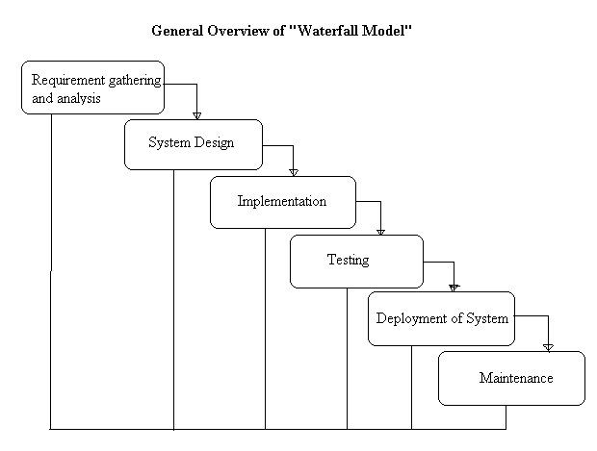

**HARDWARE SPECIFICATION**

OS Name : Microsoft Windows XP Professional

Version : 5.1.2600 Service Pack 2 Build 2600

Microprocessor : Pentium4, Pentium5

Windows : XP server runs with-128MB of RAM

**SOFTWARE SPECIFICATION**

This software has been created using:

* Front End – Visual Studio 2008
* Back End – MS-SQL

**Visual Studio 2008**:-

**Microsoft Visual Studio** is an [integrated development environment](http://en.wikipedia.org/wiki/Integrated_development_environment) (IDE) from [Microsoft](http://en.wikipedia.org/wiki/Microsoft). It can be used to develop [console](http://en.wikipedia.org/wiki/Console_application) and [graphical user interface](http://en.wikipedia.org/wiki/Graphical_user_interface) [applications](http://en.wikipedia.org/wiki/Application_software) along with [Windows Forms](http://en.wikipedia.org/wiki/Windows_Forms) applications, [web sites](http://en.wikipedia.org/wiki/Web_site), [web applications](http://en.wikipedia.org/wiki/Web_application), and [web services](http://en.wikipedia.org/wiki/Web_service) in both [native code](http://en.wikipedia.org/wiki/Native_code) together with [managed code](http://en.wikipedia.org/wiki/Managed_code) for all platforms supported by [Microsoft Windows](http://en.wikipedia.org/wiki/Microsoft_Windows), [Windows Mobile](http://en.wikipedia.org/wiki/Windows_Mobile), [Windows CE](http://en.wikipedia.org/wiki/Windows_CE), [.NET Framework](http://en.wikipedia.org/wiki/.NET_Framework), [.NET Compact Framework](http://en.wikipedia.org/wiki/.NET_Compact_Framework) and [Microsoft Silverlight](http://en.wikipedia.org/wiki/Microsoft_Silverlight).

Visual Studio includes a [code editor](http://en.wikipedia.org/wiki/Code_editor) supporting [IntelliSense](http://en.wikipedia.org/wiki/IntelliSense) as well as [code refactoring](http://en.wikipedia.org/wiki/Code_refactoring). The integrated [debugger](http://en.wikipedia.org/wiki/Microsoft_Visual_Studio_Debugger) works both as a source-level debugger and a machine-level debugger. Other built-in tools include a forms designer for building [GUI](http://en.wikipedia.org/wiki/GUI) applications, web designer, [class](http://en.wikipedia.org/wiki/Class_(computing)) designer, and [database schema](http://en.wikipedia.org/wiki/Database_schema) designer.

It accepts plug-ins that enhance the functionality at almost every level—including adding support for [source-control](http://en.wikipedia.org/wiki/Source_control) systems (like [Subversion](http://en.wikipedia.org/wiki/Subversion_(software)) and [Visual SourceSafe](http://en.wikipedia.org/wiki/Visual_SourceSafe)) and adding new toolsets like editors and visual designers for [domain-specific languages](http://en.wikipedia.org/wiki/Domain-specific_language) or toolsets for other aspects of the [software development lifecycle](http://en.wikipedia.org/wiki/Software_development_lifecycle) (like the [Team Foundation Server](http://en.wikipedia.org/wiki/Team_Foundation_Server) client: Team Explorer).

Visual Studio supports different [programming languages](http://en.wikipedia.org/wiki/Programming_language) by means of language services, which allow the code editor and debugger to support (to varying degrees) nearly any [programming language](http://en.wikipedia.org/wiki/Programming_language), provided a language-specific service exists. Built-in languages include [C](http://en.wikipedia.org/wiki/C_(programming_language))/[C++](http://en.wikipedia.org/wiki/C%2B%2B) (via [Visual C++](http://en.wikipedia.org/wiki/Visual_C%2B%2B)), [VB.NET](http://en.wikipedia.org/wiki/VB.NET) (via [Visual Basic .NET](http://en.wikipedia.org/wiki/Visual_Basic_.NET)), [C#](http://en.wikipedia.org/wiki/C_Sharp_(programming_language)) (via [Visual C#](http://en.wikipedia.org/wiki/Visual_C_Sharp)), and [F#](http://en.wikipedia.org/wiki/F_Sharp_(programming_language)) (as of Visual Studio 2010). Support for other languages such as [M](http://en.wikipedia.org/wiki/M_(programming_language)), [Python](http://en.wikipedia.org/wiki/IronPython), and [Ruby](http://en.wikipedia.org/wiki/IronRuby) among others is available via language services installed separately. It also supports [XML](http://en.wikipedia.org/wiki/XML)/[XSLT](http://en.wikipedia.org/wiki/XSLT), [HTML](http://en.wikipedia.org/wiki/HTML)/[XHTML](http://en.wikipedia.org/wiki/XHTML), [JavaScript](http://en.wikipedia.org/wiki/JavaScript) and [CSS](http://en.wikipedia.org/wiki/Cascading_Style_Sheets). Individual language-specific versions of Visual Studio also exist which provide more limited language services to the user: Microsoft Visual Basic, Visual J#, Visual C#, and Visual C++.

Microsoft provides "Express" editions of its Visual Studio 2010 components Visual Basic, Visual C#, Visual C++, and Visual Web Developer at no cost.

Visual Studio 2010, 2008 and 2005 Professional Editions, along with language-specific versions (Visual Basic, C++, C#, J#) of Visual Studio 2005 are available for free to students as downloads via Microsoft's [DreamSpark](http://en.wikipedia.org/wiki/DreamSpark) program.

Visual Basic.NET is the most recent generation of Visual Basic. Developers will be pleased to note that its new features include inheritance, method overloading, structured exception handling, and more. These capabilities make it easier than ever to create .NET applications, including Windows applications, web services, and web applications

**Structured Query Language**:-

SQL is a standardized [query language](http://www.webopedia.com/TERM/Q/query_language.html) for requesting information from a [database](http://www.webopedia.com/TERM/D/database.html). The original version called SEQUEL (***s***tructured ***E***nglish ***que***ry ***l***anguage) was designed by an [IBM](http://www.webopedia.com/TERM/I/IBM.html) research center in 1974 and 1975. SQL was first introduced as a commercial [database system](http://www.webopedia.com/TERM/D/database_management_system_DBMS.html) in 1979 by Oracle Corporation.

Historically, SQL has been the favorite query language for database management systems running on [minicomputers](http://www.webopedia.com/TERM/M/minicomputer.html) and [mainframes](http://www.webopedia.com/TERM/M/mainframe.html). Increasingly, however, SQL is being [supported](http://www.webopedia.com/TERM/S/support.html) by [PC](http://www.webopedia.com/TERM/P/PC.html) database systems because it supports [distributed databases](http://www.webopedia.com/TERM/D/distributed_database.html) (databases that are spread out over several [computer systems](http://www.webopedia.com/TERM/C/computer_system.html)). This enables several [users](http://www.webopedia.com/TERM/U/user.html) on a [local-area network](http://www.webopedia.com/TERM/L/local_area_network_LAN.html) to [access](http://www.webopedia.com/TERM/A/access.html) the same database simultaneously.

Although there are different dialects of SQL, it is nevertheless the closest thing to a [standard](http://www.webopedia.com/TERM/S/standard.html) query language that currently exists. In 1986, [ANSI](http://www.webopedia.com/TERM/A/ANSI.html) approved a rudimentary version of SQL as the official standard, but most versions of SQL since then have included many [extensions](http://www.webopedia.com/TERM/E/extension.html) to the ANSI standard. In 1991, ANSI updated the standard.

The latest version of SQL Server, **SQL Server 2008**, was released ([RTM](http://en.wikipedia.org/wiki/Software_release_life_cycle#RTM)) on August 6, 2008[[9]](http://en.wikipedia.org/wiki/Microsoft_SQL_Server#cite_note-8) and aims to make data management [self-tuning](http://en.wikipedia.org/wiki/Self-tuning), self organizing, and self maintaining with the development of *SQL Server Always On* technologies, to provide near-zero downtime. SQL Server 2008 also includes support for [structured](http://en.wikipedia.org/wiki/Structured_data) and semi-structured data, including digital media formats for pictures, audio, video and other multimedia data. In current versions, such multimedia data can be stored as [BLOBs](http://en.wikipedia.org/wiki/Binary_large_object) (binary large objects), but they are generic bitstreams.

Intrinsic awareness of multimedia data will allow specialized functions to be performed on them. According to [Paul Flessner](http://en.wikipedia.org/w/index.php?title=Paul_Flessner&action=edit&redlink=1), senior Vice President, Server Applications, [Microsoft Corp.](http://en.wikipedia.org/wiki/Microsoft), SQL Server 2008 can be a data storage backend for *different varieties of data: XML, email, time/calendar, file, document, spatial, etc* as well as perform *search, query, analysis, sharing, and synchronization* across all data types.

**EVENT TABLE**

|  |  |  |  |  |  |
| --- | --- | --- | --- | --- | --- |
| **EVENT** | **TRIGGER** | **SOURCE** | **ACTIVITY** | **RESPONSE** | **DESTINATION** |
| Add  Customer Details | New Customer  Entry | Customer | Make new Customer entry | Store Customers Details | Management |
| Add  Supplier  Details | New  Supplier  Entry | Supplier | Make new  Supplier  entry | Store Supplier Details | Management |
| Add  Product  Details | New  Product  Entry | User | Make new  Product  entry | Confirmation | Management |
| Entry for purchase | New Purchase entry | User | Update  Purchase | Confirm | Management |
| Update  Supplier  Details | Update Supplier | Management | Update Supplier | Change confirmation | User |
| Update Customer Details | Update Customer | Management | Update Customer | Change confirmation | User |
| Generate Bill Reports | Produce bill report | Management | Report Generation | Bill Reports | User |

**CONTEXT LEVEL**

**DIAGRAM**

OrderID

Customer

**Store Details**

CustId

Place Order

PIZZA SHOP

eid

Strorea Details

Employee

**DATA FLOW DIAGRAM**

**ENTITY RELATIONSHIP DIAGRAM**

Maintain

Pizza

Customers Details

Bill

Bill

Online Order

Return Order

Sale Details

Order

Order Details

Staff Details

Staff Details

Pizza Details

Stock Details

**SYSTEM FLOW DIAGRAM**

Sold Product Program

Sold Product

Store Customer Details

Customer Details

Customer Purchassing Details

Customer Details

Customer Purchassing Program

Payment Slip

Emplo**y**ee Details

Bill Report

Employee Details

Employee Program

Attendance Program

Bill Details

Bill Program

**TABLE LIST**

* Add Packing Materials:

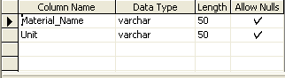

* **Burger:**

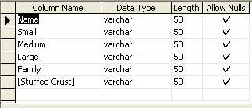

* **Cash Memo:**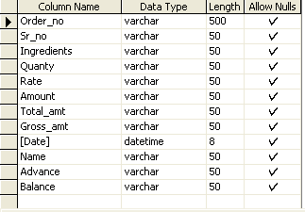
* **Customer Details:**

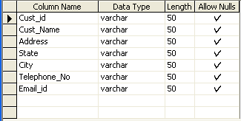

* **Customer Purchessing:**

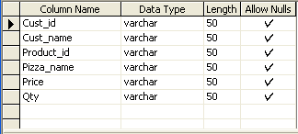

* **Employee Attendence:**

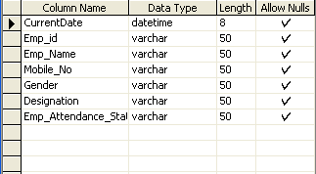

* **Employee Details:** 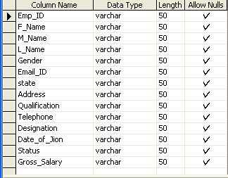
* **Inventery Details:**

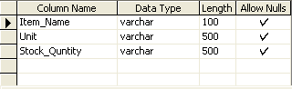

* **List of Ingredients entry:**

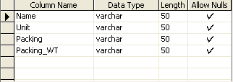

* **Login:**

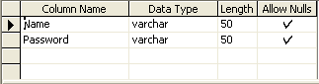

* **Meat Lovers:**

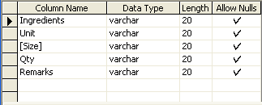

* **Non_vegpizza:**

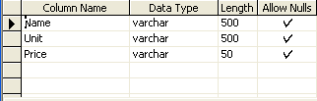

* **Pasta:**

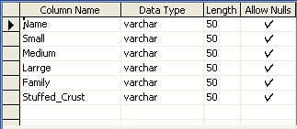

* **Payment Slip:**

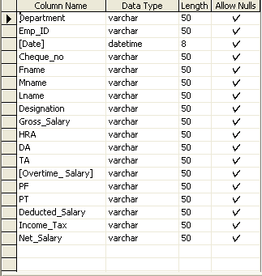

* **Pepperoni_overload**

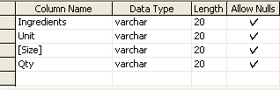

* **Product Group Price:**

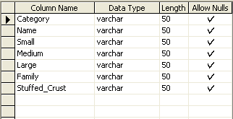

* **Product Price:**

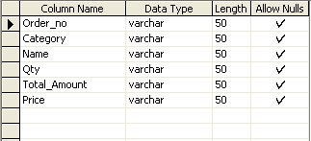

* **Purchase Item:**

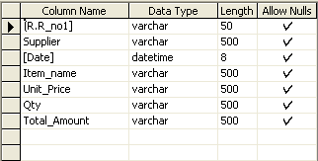

* **Relesed Item:**

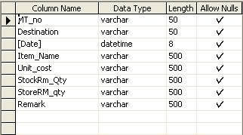

* **Salary Deducted:**

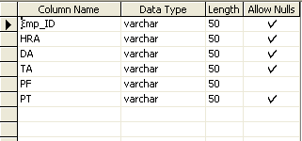

* **Selling price entry:**

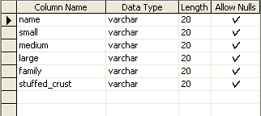

* **Sold product:**

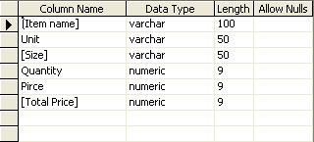

* **Supplier:**

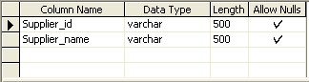

* **View sold product:**

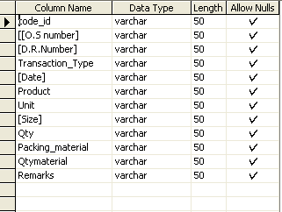

**FORM LAYOUT**

* **SPLASH SCREEN:**

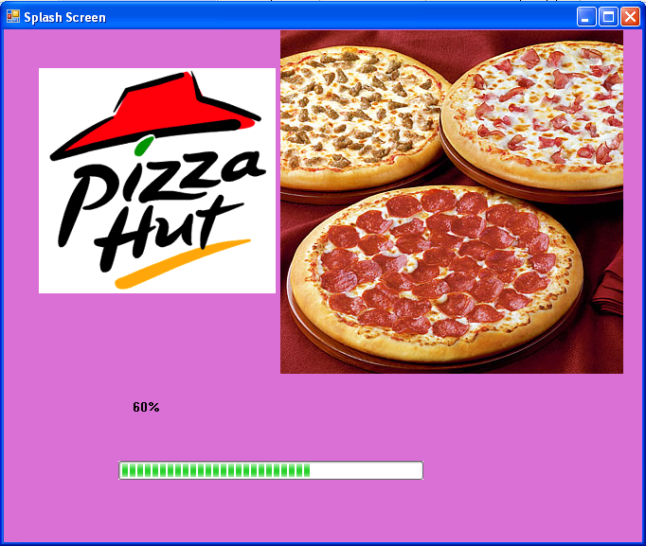

**CODING:**

Public Class splashscreen

Private Sub Timer1_Tick(ByVal sender As System.Object, ByVal e As System.EventArgs) Handles Timer1.Tick

If ProgressBar1.Value <> 100 Then

ProgressBar1.Value = ProgressBar1.Value + 2

Label2.Text = Val(ProgressBar1.Value) & "%"

End If

If ProgressBar1.Value = 100 Then

Me.Hide()

frmlogin.Show()

End If

End Sub

End Class

* **MDI FORM:**

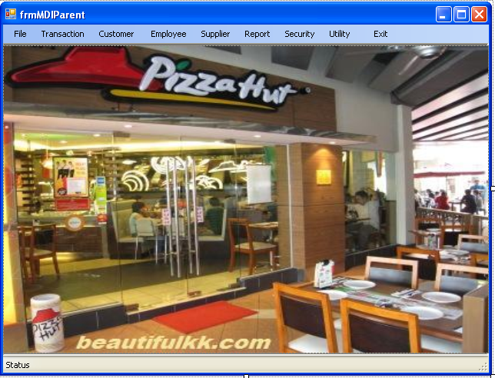

**CODING:**

Imports System.Windows.Forms

Public Class frmMDIParent

Private Sub ProductPriceToolStripMenuItem_Click(ByVal sender As System.Object, ByVal e As System.EventArgs) Handles ProductPriceToolStripMenuItem.Click

Me.Hide()

frmproductgroupprice.Show()

End Sub

Private Sub IndividualToolStripMenuItem_Click(ByVal sender As System.Object, ByVal e As System.EventArgs) Handles IndividualToolStripMenuItem.Click

Me.Hide()

frmitem.Show()

End Sub

Private Sub mnuaddnewingredient_Click(ByVal sender As System.Object, ByVal e As System.EventArgs) Handles mnuaddnewingredient.Click

Me.Hide()

frmaddingredients.Show()

End Sub

Private Sub mnuaddpackagingmaterial_Click(ByVal sender As System.Object, ByVal e As System.EventArgs) Handles mnuaddpackagingmaterial.Click

Me.Hide()

frmadd.Show()

End Sub

Private Sub mnustockroominventory_Click(ByVal sender As System.Object, ByVal e As System.EventArgs) Handles mnustockroominventory.Click

Me.Hide()

frminventorydetails.Show()

End Sub

Private Sub mnusoldproduct_Click(ByVal sender As System.Object, ByVal e As System.EventArgs) Handles mnusoldproduct.Click

Me.Hide()

frmviewsold.Show()

End Sub

Private Sub mnucustomerdetails_Click(ByVal sender As System.Object, ByVal e As System.EventArgs) Handles mnucustomerdetails.Click

Me.Hide()

frmcustomerdetails1.Show()

End Sub

Private Sub mnuemployeedetails_Click(ByVal sender As System.Object, ByVal e As System.EventArgs) Handles mnuemployeedetails.Click

Me.Hide()

frmemployeedetails.Show()

End Sub

Private Sub mnuchangepassword_Click(ByVal sender As System.Object, ByVal e As System.EventArgs) Handles mnuchangepassword.Click

Me.Hide()

frmconform.Show()

End Sub

Private Sub mnubacktologin_Click(ByVal sender As System.Object, ByVal e As System.EventArgs)

Me.Hide()

frmlogin.Show()

End Sub

Private Sub mnuexit_Click(ByVal sender As System.Object, ByVal e As System.EventArgs) Handles mnuexit.Click

End

End Sub

Private Sub mnubill_Click(ByVal sender As System.Object, ByVal e As System.EventArgs) Handles mnubill.Click

Me.Hide()

frmbill.Show()

End Sub

Private Sub mnuemployeeattendance_Click(ByVal sender As System.Object, ByVal e As System.EventArgs) Handles mnuemployeeattendance.Click

Me.Hide()

frmEmployeeAttendence.Show()

End Sub

Private Sub mnuemployeepay_Click(ByVal sender As System.Object, ByVal e As System.EventArgs) Handles mnuemployeepay.Click

Me.Hide()

frmPaymentSlip.Show()

End Sub

Private Sub mnusupplier_Click(ByVal sender As System.Object, ByVal e As System.EventArgs) Handles mnusupplier.Click

Me.Hide()

frmsuppiler.Show()

End Sub

Private Sub mnunotepad_Click(ByVal sender As System.Object, ByVal e As System.EventArgs) Handles mnunotepad.Click

Shell("notepad.exe")

End Sub

Private Sub mnuinternetexplorer_Click(ByVal sender As System.Object, ByVal e As System.EventArgs) Handles mnuinternetexplorer.Click

Shell("C:\Program Files\Internet Explorer\IEXPLORE.exe")

End Sub

Private Sub mnucalculator_Click(ByVal sender As System.Object, ByVal e As System.EventArgs) Handles mnucalculator.Click

Shell("Calc.exe")

End Sub

End Class

* **PRDUCT GROUP PRICE:**

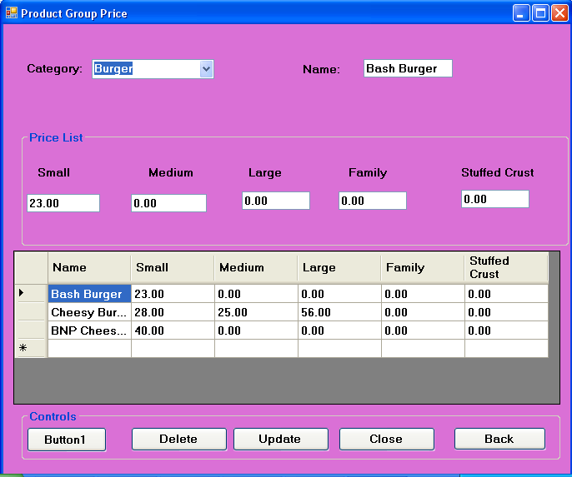

**CODING:**

Imports System.Data.Sql

Imports System.Data.SqlClient

Public Class frmproductgroupprice

Private Sub cbocategory_SelectedIndexChanged(ByVal sender As System.Object, ByVal e As System.EventArgs) Handles cbocategory.SelectedIndexChanged

Try

If cbocategory.Text = "Coffee" Then

Dim an As New SqlDataAdapter("select * from Coffee", cn)

Dim ac As New DataSet

an.Fill(ac, "Coffee")

DataGridView1.DataSource = ac.Tables("Coffee")

ElseIf cbocategory.Text = "Burger" Then

Dim an As New SqlDataAdapter("select * from Burger", cn)

Dim ac As New DataSet

an.Fill(ac, "Burger")

DataGridView1.DataSource = ac.Tables("Burger")

ElseIf cbocategory.Text = "Pizza_Perfect" Then

Dim an As New SqlDataAdapter("select * from Pizza_Perfect", cn)

Dim ac As New DataSet

an.Fill(ac, "Pizza_Perfect")

DataGridView1.DataSource = ac.Tables("Pizza_Perfect")

ElseIf cbocategory.Text = "Shakes" Then

Dim an As New SqlDataAdapter("select * from Shakes", cn)

Dim ac As New DataSet

an.Fill(ac, "Shakes")

DataGridView1.DataSource = ac.Tables("Shakes")

ElseIf cbocategory.Text = "Pasta" Then

Dim an As New SqlDataAdapter("select * from Pasta", cn)

Dim ac As New DataSet

an.Fill(ac, "Pasta")

DataGridView1.DataSource = ac.Tables("Pasta")

End If

txtname.Text = DataGridView1.CurrentRow.Cells.Item(0).Value

txtsmall.Text = DataGridView1.CurrentRow.Cells.Item(1).Value

txtmedium.Text = DataGridView1.CurrentRow.Cells.Item(2).Value

txtlarge.Text = DataGridView1.CurrentRow.Cells.Item(3).Value

txtfamily.Text = DataGridView1.CurrentRow.Cells.Item(4).Value

txtstuffedcrust.Text = DataGridView1.CurrentRow.Cells.Item(5).Value

Catch ex As Exception

MsgBox(ex.Message, MsgBoxStyle.Critical, Me.Text)

If cn.State = ConnectionState.Open Then

cn.Close()

End If

End Try

End Sub

Private Sub fmproductgroupprice_Load(ByVal sender As System.Object, ByVal e As System.EventArgs) Handles MyBase.Load

Button1.Visible = True

btnsave.Visible = False

End Sub

Private Sub btnsave_Click(ByVal sender As System.Object, ByVal e As System.EventArgs) Handles btnsave.Click

Try

Dim cmd As New SqlCommand("insert into Product_Group_Price values( '" & cbocategory.Text & " ','" & txtname.Text & "','" & txtsmall.Text & "','" & txtmedium.Text & "','" & txtlarge.Text & "','" & txtfamily.Text & "','" & txtstuffedcrust.Text & "')", cn)

cn.Open()

cmd.ExecuteNonQuery()

MsgBox("Record are successfully.....", MsgBoxStyle.OkOnly + MsgBoxStyle.Information)

cn.Close()

Dim da As New SqlDataAdapter("select * from Product_Group_Price", cn)

cn.Open()

Dim ds As New DataSet

da.Fill(ds, "Product_Group_Price")

DataGridView1.DataSource = ds.Tables(0)

cn.Close()

Catch ex As Exception

MsgBox(ex.Message, MsgBoxStyle.Critical, Me.Text)

If cn.State = ConnectionState.Open Then

cn.Close()

End If

End Try

btnsave.Visible = False

Button1.Visible = True

End Sub

Private Sub btndelete_Click(ByVal sender As System.Object, ByVal e As System.EventArgs) Handles btndelete.Click

Try

Dim cmd As New SqlCommand("Delete from Product_Group_Price where Category='" & cbocategory.Text & "'", cn)

cn.Open()

cmd.ExecuteNonQuery()

MsgBox("Successfully Record Deleted.....!", MsgBoxStyle.Information, Me.Text)

cn.Close()

txtname.Text = ""

txtsmall.Text = ""

txtmedium.Text = ""

txtlarge.Text = ""

txtfamily.Text = ""

txtstuffedcrust.Text = ""

Dim da As New SqlDataAdapter("select * from Product_Group_Price", cn)

cn.Open()

Dim ds As New DataSet

da.Fill(ds, "Product_Group_Price")

DataGridView1.DataSource = ds.Tables(0)

cn.Close()

Catch ex As Exception

MsgBox(ex.Message, MsgBoxStyle.Critical, Me.Text)

If cn.State = ConnectionState.Open Then

cn.Close()

End If

End Try

End Sub

Private Sub btnclose_Click(ByVal sender As System.Object, ByVal e As System.EventArgs) Handles btnclose.Click

End

End Sub

Private Sub btnback_Click(ByVal sender As System.Object, ByVal e As System.EventArgs) Handles btnback.Click

Me.Hide()

frmMDIParent.Show()

End Sub

Private Sub btnupdate_Click(ByVal sender As System.Object, ByVal e As System.EventArgs) Handles btnupdate.Click

Try

Dim cmd1 As New SqlCommand("update Product_Group_Price set Name='" & txtname.Text & "',Small='" & txtsmall.Text & "',Medium='" & txtmedium.Text & "',Large='" & txtlarge.Text & "',Family='" & txtfamily.Text & "',Stuffed_Crust='" & txtstuffedcrust.Text & "' where Category='" & cbocategory.Text & "'", cn)

cn.Open()

cmd1.ExecuteNonQuery()

MsgBox("record is updated")

cn.Close()

Catch ex As Exception

MsgBox(ex.Message, MsgBoxStyle.Critical, Me.Text)

If cn.State = ConnectionState.Open Then

cn.Close()

End If

End Try

End Sub

Private Sub Button1_Click(ByVal sender As System.Object, ByVal e As System.EventArgs) Handles Button1.Click

txtname.Text = DataGridView1.CurrentRow.Cells.Item(0).Value

txtsmall.Text = DataGridView1.CurrentRow.Cells.Item(1).Value

txtmedium.Text = DataGridView1.CurrentRow.Cells.Item(2).Value

txtlarge.Text = DataGridView1.CurrentRow.Cells.Item(3).Value

txtfamily.Text = DataGridView1.CurrentRow.Cells.Item(4).Value

txtstuffedcrust.Text = DataGridView1.CurrentRow.Cells.Item(5).Value

btnsave.Visible = True

Button1.Visible = False

End Sub

End Class

* **ADD INDREDIENT ITEM:**

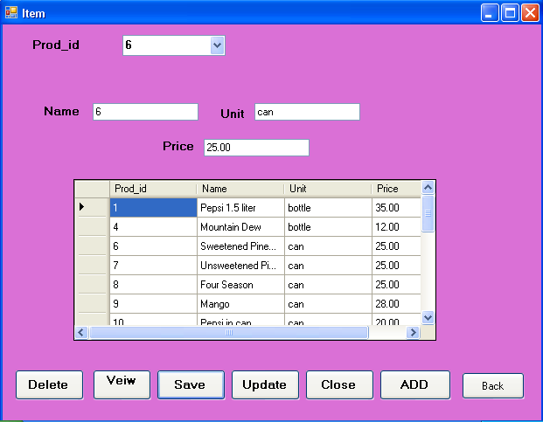

**CODING:**

Imports System.Data.Sql

Imports System.Data.SqlClient

Public Class frmitem

Private Sub cmdsave_Click(ByVal sender As System.Object, ByVal e As System.EventArgs) Handles btnsave.Click

Dim cmd As New SqlCommand("insert into Price_List_Item_Entry values( '" & cboprodid.Text & " ','" & txtname.Text & "','" & txtunit.Text & "','" & txtprice.Text & "')", cn)

cn.Open()

cmd.ExecuteNonQuery()

MsgBox("Record are successfully.....", MsgBoxStyle.OkOnly + MsgBoxStyle.Information)

cn.Close()

End Sub

Private Sub cboprodname_SelectedIndexChanged(ByVal sender As System.Object, ByVal e As System.EventArgs) Handles cboprodid.SelectedIndexChanged

Dim cmd As New SqlCommand("select * from Price_List_Item_Entry where prod_id='" & cboprodid.Text & "'", cn)

cn.Open()

Dim dr As SqlDataReader = cmd.ExecuteReader

While dr.Read

txtname.Text = dr.GetString(0)

txtunit.Text = dr.GetString(2)

txtprice.Text = dr.GetString(3)

End While

dr.Close()

cn.Close()

End Sub

Private Sub frmitem_Load(ByVal sender As System.Object, ByVal e As System.EventArgs) Handles MyBase.Load

Dim cmd As New SqlCommand("select * from Price_List_Item_Entry", cn)

cn.Open()

Dim dr As SqlDataReader = cmd.ExecuteReader

While dr.Read

cboprodid.Items.Add(dr.GetString(0))

End While

dr.Close()

cn.Close()

End Sub

Private Sub Btnveiwall_Click(ByVal sender As System.Object, ByVal e As System.EventArgs) Handles btnveiwall.Click

Try

Dim da As New SqlDataAdapter("select * from Price_List_Item_Entry", cn)

cn.Open()

Dim ds As New DataSet

da.Fill(ds, "Price_List_Item_Entry")

datagridview.DataSource = ds.Tables(0)

cn.Close()

Catch ex As Exception

MsgBox(ex.Message, MsgBoxStyle.Critical, Me.Text)

If cn.State = ConnectionState.Open Then

cn.Close()

End If

End Try

End Sub

Private Sub btnclose_Click(ByVal sender As System.Object, ByVal e As System.EventArgs) Handles btnclose.Click

End

End Sub

Private Sub btndelete_Click(ByVal sender As System.Object, ByVal e As System.EventArgs) Handles btndelete.Click

Try

Dim cmd As New SqlCommand("Delete from Price_List_Item_Entry where Prod_id='" & cboprodid.Text & "'", cn)

cn.Open()

cmd.ExecuteNonQuery()

MsgBox("Successfully Record Deleted.....!", MsgBoxStyle.Information, Me.Text)

cn.Close()

txtname.Text = ""

txtunit.Text = ""

txtprice.Text = ""

Catch ex As Exception

MsgBox(ex.Message, MsgBoxStyle.Critical, Me.Text)

If cn.State = ConnectionState.Open Then

cn.Close()

End If

End Try

End Sub

Private Sub cmdupdate_Click(ByVal sender As System.Object, ByVal e As System.EventArgs) Handles btnupdate.Click

Dim cmd1 As New SqlCommand("update Price_List_Item_Entry set Name='" & txtname.Text & "',unit='" & txtunit.Text & "',price='" & txtprice.Text & "' where prod_id='" & cboprodid.Text & "'", cn)

cn.Open()

cmd1.ExecuteNonQuery()

MsgBox("record is updated")

cn.Close()

End Sub

Private Sub btnadd_Click(ByVal sender As System.Object, ByVal e As System.EventArgs) Handles btnadd.Click, btnadd.Click

Dim rec As New SqlCommand("select * from Price_List_Item_Entry", cn)

cn.Open()

Dim dr As SqlDataReader = rec.ExecuteReader

While dr.Read

txtprodid.Text = dr(0)

End While

txtprodid.Text = "00" & Val(txtprodid.Text) + 1

dr.Close()

cn.Close()

txtprodid.Enabled = False

End Sub

Private Sub btnback_Click(ByVal sender As System.Object, ByVal e As System.EventArgs) Handles btnback.Click

Me.Hide()

frmMdiParent.Show()

End Sub

End Class

* **ADD NEW INGREDIENT:**

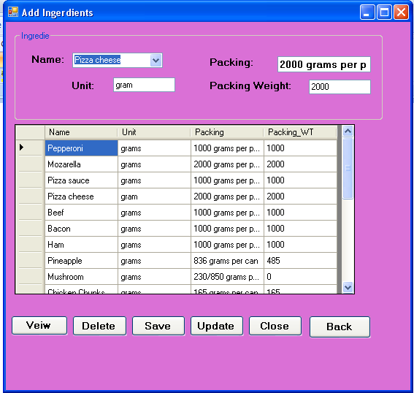

**CODING:**

Imports System.Data.Sql

Imports System.Data.SqlClient

Public Class frmaddingredients

Dim i As String

Private Sub Form1_Load(ByVal sender As System.Object, ByVal e As System.EventArgs) Handles MyBase.Load

Dim cmd As New SqlCommand("select * from List_of_Ingredients_entry", cn)

cn.Open()

Dim dr As SqlDataReader = cmd.ExecuteReader

While dr.Read

cboname.Items.Add(dr.GetString(0))

End While

dr.Close()

cn.Close()

End Sub

Private Sub cmdsave_Click(ByVal sender As System.Object, ByVal e As System.EventArgs) Handles cmdsave.Click

If cboname.Text = "" Or txtunit.Text = "" Or txtpacking.Text = "" Or txtpackingweigth.Text = "" Then

MsgBox("Enter the feild properly", MsgBoxStyle.Information)

Else

Dim cmd As New SqlCommand("insert into List_of_Ingredients_entry values('" & cboname.Text & "','" & txtunit.Text & "','" & txtpacking.Text & "','" & txtpackingweigth.Text & "')", cn)

cn.Open()

cmd.ExecuteNonQuery()

MsgBox("RECORD SAVED", MsgBoxStyle.OkOnly + MsgBoxStyle.Information, "SAVED")

Dim da As New SqlDataAdapter("select * from List_of_Ingredients_entry", cn)

Dim ds As New DataSet

da.Fill(ds, "List_of_Ingredients_entry")

dgv.DataSource = ds.Tables(0)

cboname.Text = ""

txtunit.Text = ""

txtpacking.Text = ""

txtpackingweigth.Text = ""

cboname.Focus()

End If

End Sub

Private Sub cmdupdate_Click(ByVal sender As System.Object, ByVal e As System.EventArgs) Handles cmdupdate.Click

Dim cmd As New SqlCommand("update List_of_Ingredients_entry set Unit='" & dgv.CurrentRow.Cells.Item(1).Value & "',Packing='" & dgv.CurrentRow.Cells.Item(2).Value & "',Packing_WT='" & dgv.CurrentRow.Cells.Item(3).Value & "' where Name='" & i & "'", cn)

cn.Open()

cmd.ExecuteNonQuery()

MsgBox("Record are updated successfully......")

cn.Close()

Dim da As New SqlDataAdapter("select * from List_of_Ingredients_entry", cn)

Dim ds As New DataSet

da.Fill(ds, "List_of_Ingredients_entry")

dgv.DataSource = ds.Tables(0)

End Sub

Private Sub btndelete_Click(ByVal sender As System.Object, ByVal e As System.EventArgs) Handles btndelete.Click

Try

Dim cmd As New SqlCommand("Delete from List_of_Ingredients_entry where name='" & cboname.Text & "'", cn)

cn.Open()

cmd.ExecuteNonQuery()

MsgBox("Successfully Record Deleted.....!", MsgBoxStyle.Information, Me.Text)

cn.Close()

Dim da As New SqlDataAdapter("select * from List_of_Ingredients_entry", cn)

Dim ds As New DataSet

da.Fill(ds, "List_of_Ingredients_entry")

dgv.DataSource = ds.Tables(0)

Catch ex As Exception

MsgBox(ex.Message, MsgBoxStyle.Critical, Me.Text)

If cn.State = ConnectionState.Open Then

cn.Close()

End If

End Try

End Sub

Private Sub cmdclose_Click(ByVal sender As System.Object, ByVal e As System.EventArgs) Handles cmdclose.Click

End

End Sub

Private Sub btnveiw_Click(ByVal sender As System.Object, ByVal e As System.EventArgs) Handles btnveiw.Click

Dim da As New SqlDataAdapter("select * from List_of_Ingredients_entry", cn)

Dim ds As New DataSet

da.Fill(ds, "List_of_Ingredients_entry")

dgv.DataSource = ds.Tables(0)

End Sub

Private Sub dgv_ColumnHeaderMouseClick(ByVal sender As Object, ByVal e As System.Windows.Forms.DataGridViewCellMouseEventArgs) Handles dgv.ColumnHeaderMouseClick

i = InputBox("please enter the name of the product")

Dim da As New SqlDataAdapter("select * from List_of_Ingredients_entry where name='" & i & "'", cn)

Dim ds As New DataSet

da.Fill(ds, "List_of_Ingredients_entry")

dgv.DataSource = ds.Tables(0)

End Sub

Private Sub cboname_SelectedIndexChanged(ByVal sender As System.Object, ByVal e As System.EventArgs) Handles cboname.SelectedIndexChanged

Dim cmd As New SqlCommand("select * from List_of_Ingredients_entry where name='" & cboname.Text & "'", cn)

cn.Open()

Dim dr As SqlDataReader = cmd.ExecuteReader

While dr.Read

cboname.Text = dr.GetString(0)

txtunit.Text = dr.GetString(1)

txtpacking.Text = dr.GetString(2)

txtpackingweigth.Text = dr.GetString(3)

End While

dr.Close()

cn.Close()

Dim da As New SqlDataAdapter("select * from List_of_Ingredients_entry", cn)

Dim ds As New DataSet

da.Fill(ds, "List_of_Ingredients_entry")

dgv.DataSource = ds.Tables(0)

End Sub

Private Sub btnback_Click(ByVal sender As System.Object, ByVal e As System.EventArgs) Handles btnback.Click

Me.Hide()

frmMdiParent.Show()

End Sub

End Class

* **ADD PACKING MATERIAL:**

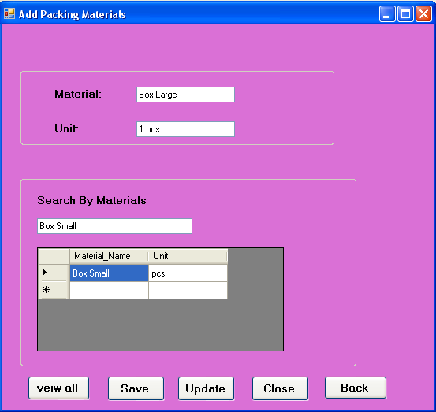

**CODING:**

Imports System.Data.Sql

Imports System.Data.SqlClient

Public Class frmadd

Private Sub btnsave_Click(ByVal sender As System.Object, ByVal e As System.EventArgs) Handles btnsave.Click

Try

Dim cmdsave As New SqlCommand("insert into add_packing_materials values('" & txtmaterial.Text & "','" & txtunit.Text & "')", cn)

cn.Open()

cmdsave.ExecuteNonQuery()

MsgBox("Records are successfully.....", MsgBoxStyle.OkOnly + MsgBoxStyle.Information)

cn.Close()

Catch ex As Exception

MsgBox(ex.Message, MsgBoxStyle.Critical, Me.Text)

If cn.State = ConnectionState.Open Then

cn.Close()

End If

End Try

End Sub

Private Sub Button1_Click(ByVal sender As System.Object, ByVal e As System.EventArgs) Handles btnveiwall.Click

Try

Dim da As New SqlDataAdapter("select * from add_packing_materials", cn)

Dim ds As New DataSet

da.Fill(ds, "add_packing_materials")

DataGridView1.DataSource = ds.Tables(0)

Catch ex As Exception

MsgBox(ex.Message, MsgBoxStyle.Critical, Me.Text)

If cn.State = ConnectionState.Open Then

cn.Close()

End If

End Try

End Sub

Private Sub btnupdate_Click(ByVal sender As System.Object, ByVal e As System.EventArgs) Handles btnupdate.Click

End Sub

Private Sub btnclose_Click(ByVal sender As System.Object, ByVal e As System.EventArgs) Handles btnclose.Click

End

End Sub

Private Sub txtsearch_TextChanged(ByVal sender As System.Object, ByVal e As System.EventArgs) Handles txtsearch.TextChanged

Dim cmd As New SqlDataAdapter("select * from add_packing_materials where Material_Name='" & txtsearch.Text & "'", cn)

Dim ds1 As New DataSet

cmd.Fill(ds1, "add_packing_materials")

DataGridView1.DataSource = ds1.Tables("add_packing_materials")

End Sub

Private Sub btnback_Click(ByVal sender As System.Object, ByVal e As System.EventArgs) Handles btnback.Click

Me.Hide()

frmMdiParent.Show()

End Sub

End Class

* **INVENTORY DETAILS:**

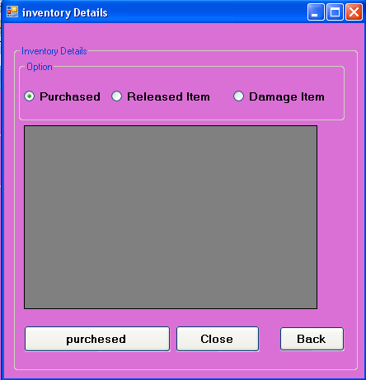

**CODING:**

Imports System.Data.Sql

Imports System.Data.SqlClient

Public Class frminventorydetails

Private Sub optpurchesed_CheckedChanged(ByVal sender As System.Object, ByVal e As System.EventArgs) Handles optpurchased.CheckedChanged

btnpurchased.Text = "purchesed"

End Sub

Private Sub optreleaseditem_CheckedChanged(ByVal sender As System.Object, ByVal e As System.EventArgs) Handles optreleaseditem.CheckedChanged

btnpurchased.Text = "Relesed Item"

End Sub

Private Sub optdamageitem_CheckedChanged(ByVal sender As System.Object, ByVal e As System.EventArgs) Handles optdamageitem.CheckedChanged

btnpurchased.Text = "Deleted Item"

End Sub

Private Sub btnpurchased_Click(ByVal sender As System.Object, ByVal e As System.EventArgs) Handles btnpurchased.Click

Dim cmd As New SqlCommand(" select * from Stock_Room_Inventory ", cn)

cn.Open()

If btnpurchased.Text = "purchesed" Then

frmpurchesitem.Show()

ElseIf btnpurchased.Text = "Relesed Item" Then

frmreleseditem.Show()

ElseIf btnpurchased.Text = "Deleted Item" Then

frmdamageitem.Show()

End If

cn.Close()

End Sub

Private Sub cmdclose_Click(ByVal sender As System.Object, ByVal e As System.EventArgs) Handles cmdclose.Click

End

End Sub

Private Sub btnback_Click(ByVal sender As System.Object, ByVal e As System.EventArgs) Handles btnback.Click

Me.Hide()

frmMDIParent.Show()

End Sub

End Class

* **PURCHASE ITEM:**

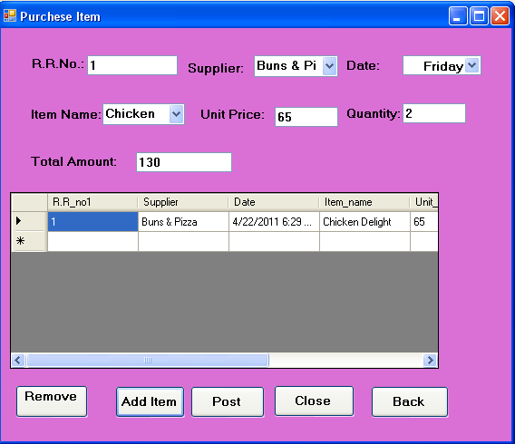

**CODING:**

Imports System.Data.Sql

Imports System.Data.SqlClient

Public Class frmpurchesitem

Private Sub btnclose_Click(ByVal sender As System.Object, ByVal e As System.EventArgs) Handles btnclose.Click

End

End Sub

Private Sub btnpost_Click(ByVal sender As System.Object, ByVal e As System.EventArgs) Handles btnpost.Click

MsgBox("Are you sure to post a previous form", MsgBoxStyle.Information)

frminventorydetails.Show()

Me.Hide()

End Sub

Private Sub cbosuppiler_SelectedIndexChanged(ByVal sender As System.Object, ByVal e As System.EventArgs) Handles cbosuppiler.SelectedIndexChanged

Dim cmd As New SqlCommand("select * from Supplier where Supplier_name='" & cbosuppiler.Text & "'", cn)

cn.Open()

Dim dr As SqlDataReader = cmd.ExecuteReader

While dr.Read

cbosuppiler.Text = dr.GetString(1)

End While

dr.Close()

cn.Close()

End Sub

Private Sub frmitem_Load(ByVal sender As System.Object, ByVal e As System.EventArgs) Handles MyBase.Load

Dim da As New SqlDataAdapter("select * from purchaseitem", cn)

Dim ds As New DataSet

da.Fill(ds, "purchaseitem")

DataGridView1.DataSource = ds.Tables("purchaseitem")

Dim cmd As New SqlCommand("select * from Supplier", cn)

cn.Open()

Dim dr As SqlDataReader = cmd.ExecuteReader

While dr.Read

cbosuppiler.Items.Add(dr.GetString(1))

End While

dr.Close()

cn.Close()

Dim cmdsr As New SqlCommand("Select * from selling_price_entry ", cn)

cn.Open()

Dim drsr As SqlDataReader = cmdsr.ExecuteReader

While drsr.Read

cboname.Items.Add(drsr.GetString(0))

End While

drsr.Close()

cn.Close()

End Sub

Private Sub btnadd_Click(ByVal sender As System.Object, ByVal e As System.EventArgs) Handles btnadd.Click

If txtrrno.Text = "" Then

MsgBox(" Do not accept empty feiled ")

End If

Dim da As New SqlDataAdapter("select * from purchaseitem", cn)

If txtrrno.Text = "" Or cbosuppiler.Text = "" Or cboname.Text = "" Or txtunit.Text = "" Or txtqty.Text = "" Then

MsgBox("The R.R. No. is not accpt empty feild!")

End If

Dim cmd As New SqlCommand("insert into purchaseitem values('" & txtrrno.Text & " ','" & cbosuppiler.Text & "','" & DateTimePicker1.Value & "','" & cboname.Text & "','" & txtunit.Text & "','" & txtqty.Text & "','" & txttotal.Text & "')", cn)

cn.Open()

cmd.ExecuteNonQuery()

MsgBox("Record are successfully.....", MsgBoxStyle.OkOnly + MsgBoxStyle.Information)

cn.Close()

Dim da1 As New SqlDataAdapter("select * from purchaseitem", cn)

Dim ds As New DataSet

da1.Fill(ds, "purchaseitem")

DataGridView1.DataSource = ds.Tables("purchaseitem")

End Sub

Private Sub cboname_SelectedIndexChanged(ByVal sender As System.Object, ByVal e As System.EventArgs) Handles cboname.SelectedIndexChanged

Dim cmd As New SqlCommand("select * from selling_price_entry where name='" & cboname.Text & "'", cn)

cn.Open()

Dim dr As SqlDataReader = cmd.ExecuteReader

While dr.Read

cboname.Text = dr.GetString(0)

End While

dr.Close()

cn.Close()

End Sub

Private Sub btnremove_Click(ByVal sender As System.Object, ByVal e As System.EventArgs) Handles btnremove.Click

Try

Dim cmd As New SqlCommand("Delete from purchaseitem where Supplier='" & cbosuppiler.Text & "'", cn)

cn.Open()

cmd.ExecuteNonQuery()

MsgBox("Successfully Record Deleted.....!", MsgBoxStyle.Information, Me.Text)

cn.Close()

txtrrno.Text = ""

cbosuppiler.Text = ""

DateTimePicker1.Value = Now

cboname.Text = ""

txtunit.Text = ""

txtqty.Text = ""

txttotal.Text = ""

Dim da As New SqlDataAdapter("select * from purchaseitem", cn)

Dim ds As New DataSet

da.Fill(ds, "purchaseitem")

DataGridView1.DataSource = ds.Tables("purchaseitem")

Catch ex As Exception

MsgBox(ex.Message, MsgBoxStyle.Critical, Me.Text)

If cn.State = ConnectionState.Open Then

cn.Close()

End If

End Try

End Sub

End Class

* **RELESED ITEM:**

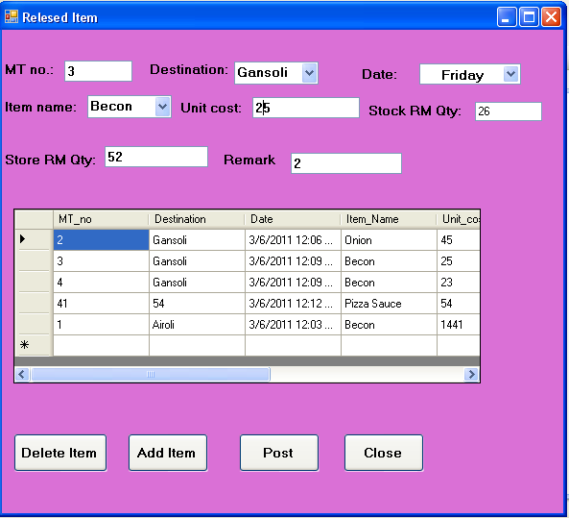

**CODING:**

Imports System.Data.Sql

Imports System.Data.SqlClient

Public Class frmreleseditem

Private Sub cbodes_SelectedIndexChanged(ByVal sender As System.Object, ByVal e As System.EventArgs) Handles cbodes.SelectedIndexChanged

Dim cmd As New SqlCommand("select * from Destination where Destination_name='" & cbodes.Text & "'", cn)

cn.Open()

Dim dr As SqlDataReader = cmd.ExecuteReader

While dr.Read

cbodes.Text = dr.GetString(0)

End While

dr.Close()

cn.Close()

End Sub

Private Sub frmreleseditem_Load(ByVal sender As System.Object, ByVal e As System.EventArgs) Handles MyBase.Load

Dim da As New SqlDataAdapter("select * from Relesed_item", cn)

Dim ds As New DataSet

da.Fill(ds, "Relesed_item")

DataGridView1.DataSource = ds.Tables("Relesed_item")

Dim cmd As New SqlCommand("select * from Destination", cn)

cn.Open()

Dim dr As SqlDataReader = cmd.ExecuteReader

While dr.Read

cbodes.Items.Add(dr.GetString(0))

End While

dr.Close()

cn.Close()

Dim cmdsr As New SqlCommand("Select * from Meat_Lovers ", cn)

cn.Open()

Dim drsr As SqlDataReader = cmdsr.ExecuteReader

While drsr.Read

cboname.Items.Add(drsr.GetString(0))

End While

drsr.Close()

cn.Close()

End Sub

Private Sub cboname_SelectedIndexChanged(ByVal sender As System.Object, ByVal e As System.EventArgs) Handles cboname.SelectedIndexChanged

Dim cmd As New SqlCommand("select * from Meat_Lovers where Ingredients='" & cboname.Text & "'", cn)

cn.Open()

Dim dr As SqlDataReader = cmd.ExecuteReader

While dr.Read

cboname.Text = dr.GetString(0)

End While

dr.Close()

cn.Close()

End Sub

Private Sub btnadd_Click(ByVal sender As System.Object, ByVal e As System.EventArgs) Handles btnadd.Click

If txtmt.Text = "" Or cbodes.Text = "" Or cboname.Text = "" Or txtunit.Text = "" Or txtstock.Text = "" Or txtstore.Text = "" Or txtremark.Text = "" Then

MsgBox("Enter the feild properly", MsgBoxStyle.Information)

Else

Dim cmds As New SqlCommand("insert into Relesed_item values('" & txtmt.Text & "','" & cbodes.Text & "','" & DateTimePicker1.Value & "','" & cboname.Text & "','" & txtunit.Text & "','" & txtstock.Text & "','" & txtstore.Text & "','" & txtremark.Text & "')", cn)

cn.Open()

cmds.ExecuteNonQuery()

MsgBox("record are succesfully added......", MsgBoxStyle.Information)

cn.Close()

Dim da As New SqlDataAdapter("select * from Relesed_item", cn)

Dim ds As New DataSet

da.Fill(ds, "Relesed_item")

DataGridView1.DataSource = ds.Tables("Relesed_item")

txtmt.Text = ""

cbodes.Text = ""

DateTimePicker1.Value = Now

cboname.Text = ""

txtunit.Text = ""

txtstock.Text = ""

txtstore.Text = ""

txtremark.Text = ""

End If

End Sub

Private Sub btndetete_Click(ByVal sender As System.Object, ByVal e As System.EventArgs) Handles btndetete.Click

Try

Dim cmd As New SqlCommand("Delete from Relesed_item where Destination='" & cbodes.Text & "'", cn)

cn.Open()

cmd.ExecuteNonQuery()

MsgBox("Successfully Record Deleted.....!", MsgBoxStyle.Information, Me.Text)

cn.Close()

txtmt.Text = ""

cbodes.Text = ""

DateTimePicker1.Value = Now

cboname.Text = ""

txtunit.Text = ""

txtstock.Text = ""

txtstore.Text = ""

txtremark.Text = ""

Dim da As New SqlDataAdapter("select * from Relesed_item", cn)

Dim ds As New DataSet

da.Fill(ds, "Relesed_item")

DataGridView1.DataSource = ds.Tables("Relesed_item")

Catch ex As Exception

MsgBox(ex.Message, MsgBoxStyle.Critical, Me.Text)

If cn.State = ConnectionState.Open Then

cn.Close()

End If

End Try

End Sub

Private Sub btnpost_Click(ByVal sender As System.Object, ByVal e As System.EventArgs) Handles btnpost.Click

MsgBox("Are you sure to post a previous form", MsgBoxStyle.Information)

frminventorydetails.Show()

Me.Hide()

End Sub

Private Sub btnclose_Click(ByVal sender As System.Object, ByVal e As System.EventArgs) Handles btnclose.Click

End

End Sub

End Class

* **DELETE ITEM:**

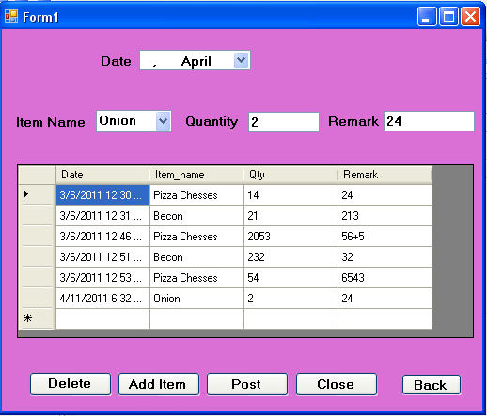

**CODING:**

Imports System.Data.Sql

Imports System.Data.SqlClient

Public Class frmdamageitem

Private Sub btnpost_Click(ByVal sender As System.Object, ByVal e As System.EventArgs) Handles btnpost.Click

MsgBox("Are you sure to post a previous form", MsgBoxStyle.Information)

frminventorydetails.Show()

Me.Hide()

End Sub

Private Sub btndelete_Click(ByVal sender As System.Object, ByVal e As System.EventArgs) Handles btndelete.Click

Try

Dim cmd As New SqlCommand("Delete from Delete_item where Item_name='" & cboname.Text & "'", cn)

cn.Open()

cmd.ExecuteNonQuery()

MsgBox("Successfully Record Deleted.....!", MsgBoxStyle.Information, Me.Text)

cn.Close()

DateTimePicker1.Value = Now

cboname.Text = ""

txtqty.Text = ""

txtremark.Text = ""

Dim da As New SqlDataAdapter("select * from Delete_item", cn)

Dim ds As New DataSet

da.Fill(ds, "Delete_item")

DataGridView1.DataSource = ds.Tables("Delete_item")

Catch ex As Exception

MsgBox(ex.Message, MsgBoxStyle.Critical, Me.Text)

If cn.State = ConnectionState.Open Then

cn.Close()

End If

End Try

End Sub

Private Sub cboname_SelectedIndexChanged(ByVal sender As System.Object, ByVal e As System.EventArgs) Handles cboname.SelectedIndexChanged

Dim cmd As New SqlCommand("select * from Meat_Lovers where Ingredients='" & cboname.Text & "'", cn)

cn.Open()

Dim dr As SqlDataReader = cmd.ExecuteReader

While dr.Read

cboname.Text = dr.GetString(0)

End While

dr.Close()

cn.Close()

End Sub

Private Sub frmdamageitem_Load(ByVal sender As System.Object, ByVal e As System.EventArgs) Handles MyBase.Load

Dim da As New SqlDataAdapter("select * from Delete_item", cn)

Dim ds As New DataSet

da.Fill(ds, "Delete_item")

DataGridView1.DataSource = ds.Tables("Delete_item")

Dim cmdsr As New SqlCommand("Select * from Meat_Lovers ", cn)

cn.Open()

Dim drsr As SqlDataReader = cmdsr.ExecuteReader

While drsr.Read

cboname.Items.Add(drsr.GetString(0))

End While

drsr.Close()

cn.Close()

End Sub

Private Sub btnadd_Click(ByVal sender As System.Object, ByVal e As System.EventArgs) Handles btnadd.Click

If cboname.Text = "" Or txtqty.Text = "" Or txtremark.Text = "" Then

MsgBox("Enter the feild properly", MsgBoxStyle.Information)

Else

Dim cmds As New SqlCommand("insert into Delete_item values('" & DateTimePicker1.Value & "','" & cboname.Text & "','" & txtqty.Text & "','" & txtremark.Text & "')", cn)

cn.Open()

cmds.ExecuteNonQuery()

MsgBox("record are succesfully added......", MsgBoxStyle.Information)

cn.Close()

Dim da As New SqlDataAdapter("select * from Delete_item", cn)

Dim ds As New DataSet

da.Fill(ds, "Delete_item")

DataGridView1.DataSource = ds.Tables("Delete_item")

DateTimePicker1.Value = Now

cboname.Text = ""

txtqty.Text = ""

txtremark.Text = ""

End If

End Sub

Private Sub btnback_Click(ByVal sender As System.Object, ByVal e As System.EventArgs) Handles btnback.Click

Me.Hide()

frmMdiParent.Show()

End Sub

End Class

* **VIEW SOLD:**

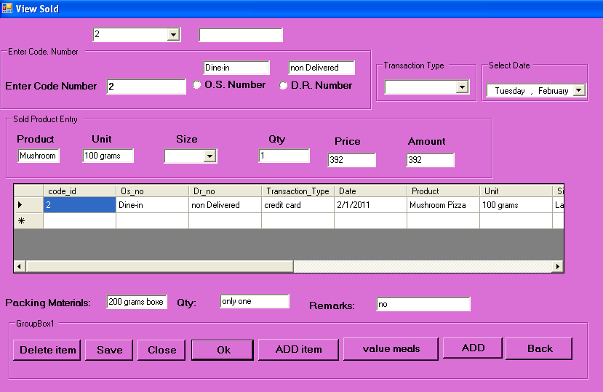

**CODING:**

Imports System.Data.Sql

Imports System.Data.SqlClient

Public Class frmviewsold

Private Sub btnok_Click(ByVal sender As System.Object, ByVal e As System.EventArgs)

End Sub

Private Sub btndelete_Click(ByVal sender As System.Object, ByVal e As System.EventArgs)

Try

Dim cmd As New SqlCommand("Delete from view_sold_product where code_id='" & cbocodeno.Text & "'", cn)

cn.Open()

cmd.ExecuteNonQuery()

MsgBox("Successfully Record Deleted.....!", MsgBoxStyle.Information, Me.Text)

cn.Close()

cbocodeno.Text = ""

txtcode.Text = ""

TextBox1.Text = ""

TextBox2.Text = ""

cbotransactiontype.Text = ""

DateTimePicker1.Value = Now

txtproduct.Text = ""

txtunit.Text = ""

cbosize.Text = ""

txtqty.Text = ""

txtpacking.Text = ""

txtqtymaterials.Text = ""

txtremarks.Text = ""

Catch ex As Exception

MsgBox(ex.Message, MsgBoxStyle.Critical, Me.Text)

If cn.State = ConnectionState.Open Then

cn.Close()

End If

End Try

End Sub

Private Sub btnsave_Click(ByVal sender As System.Object, ByVal e As System.EventArgs)

End Sub

Private Sub btnclose_Click(ByVal sender As System.Object, ByVal e As System.EventArgs)

End

End Sub

Private Sub cbocodeno_SelectedIndexChanged(ByVal sender As System.Object, ByVal e As System.EventArgs) Handles cbocodeno.SelectedIndexChanged

Dim cmd As New SqlCommand("select * from view_sold_product where code_id='" & cbocodeno.Text & "'", cn)

cn.Open()

Dim dr As SqlDataReader = cmd.ExecuteReader

While dr.Read

txtcode.Text = dr.GetString(0)

TextBox1.Text = dr.GetString(1)

TextBox2.Text = dr.GetString(2)

DateTimePicker1.Value = dr.GetString(4)

txtproduct.Text = dr.GetString(5)

txtunit.Text = dr.GetString(6)

txtqty.Text = dr.GetString(8)

txtprice.Text = dr.GetString(9)

txtamount.Text = dr.GetString(10)

txtpacking.Text = dr.GetString(11)

txtqtymaterials.Text = dr.GetString(12)

txtremarks.Text = dr.GetString(13)

End While

dr.Close()

cn.Close()

End Sub

Private Sub cbosize_SelectedIndexChanged(ByVal sender As System.Object, ByVal e As System.EventArgs) Handles cbosize.SelectedIndexChanged

If cn.State = ConnectionState.Open Then

cn.Close()

End If

Dim cmd As New SqlCommand("select * from view_sold_product where size='" & cbosize.Text & "'", cn)

cn.Open()

Dim dr5 As SqlDataReader = cmd.ExecuteReader

While dr5.Read

txtcode.Text = dr5.GetString(0)

TextBox1.Text = dr5.GetString(1)

TextBox2.Text = dr5.GetString(2)

DateTimePicker1.Value = dr5(4)

txtproduct.Text = dr5.GetString(5)

txtunit.Text = dr5.GetString(6)

txtqty.Text = dr5(8)

txtprice.Text = dr5.GetString(9)

txtpacking.Text = dr5.GetString(11)

txtqtymaterials.Text = dr5.GetString(12)

txtremarks.Text = dr5.GetString(13)

End While

dr5.Close()

cn.Close()

End Sub

Private Sub frmviewsold_Load(ByVal sender As System.Object, ByVal e As System.EventArgs) Handles MyBase.Load

Dim cmd As New SqlCommand("select * from view_sold_product", cn)

cn.Open()

Dim dr As SqlDataReader = cmd.ExecuteReader

While dr.Read

cbocodeno.Items.Add(dr.GetString(0))

cbosize.Items.Add(dr.GetString(7))

cbotransactiontype.Items.Add(dr.GetString(3))

End While

dr.Close()

cn.Close()

End Sub

Private Sub cbotransactiontype_SelectedIndexChanged(ByVal sender As System.Object, ByVal e As System.EventArgs) Handles cbotransactiontype.SelectedIndexChanged

If cn.State = ConnectionState.Open Then

cn.Close()

End If

Dim cmd As New SqlCommand("select * from view_sold_product where Transaction_Type='" & cbotransactiontype.Text & "'", cn)

cn.Open()

Dim dr4 As SqlDataReader = cmd.ExecuteReader

While dr4.Read

txtcode.Text = dr4.GetString(0)

TextBox1.Text = dr4.GetString(1)

TextBox2.Text = dr4.GetString(2)

DateTimePicker1.Value = dr4(4)

txtproduct.Text = dr4.GetString(5)

txtunit.Text = dr4.GetString(6)

txtqty.Text = dr4.GetString(8)

txtprice.Text = dr4.GetString(9)

txtpacking.Text = dr4.GetString(11)

txtqtymaterials.Text = dr4.GetString(12)

txtremarks.Text = dr4.GetString(13)

End While

dr4.Close()

cn.Close()

End Sub

Private Sub btnback_Click(ByVal sender As System.Object, ByVal e As System.EventArgs) Handles btnback.Click

Me.Hide()

frmMDIParent.Show()

End Sub

Private Sub Button1_Click_1(ByVal sender As System.Object, ByVal e As System.EventArgs) Handles Button1.Click

Me.Hide()

searchveiwsold.Show()

End Sub

Private Sub txtamount_GotFocus(ByVal sender As Object, ByVal e As System.EventArgs) Handles txtamount.GotFocus

txtamount.Text = Val(txtqty.Text) * Val(txtprice.Text)

End Sub

Private Sub btnsave_Click_1(ByVal sender As System.Object, ByVal e As System.EventArgs) Handles btnsave.Click

Try

Dim cmdsave As New SqlCommand("insert into view_sold_product values('" & txtcodeno.Text & "','" & TextBox1.Text & "','" & TextBox2.Text & " ',' " & cbotransactiontype.Text & "','" & DateTimePicker1.Value & "','" & txtproduct.Text & "','" & txtunit.Text & "','" & cbosize.Text & "','" & txtqty.Text & "','" & txtprice.Text & "','" & txtamount.Text & "','" & txtpacking.Text & "','" & txtqtymaterials.Text & "','" & txtremarks.Text & "')", cn)

cn.Open()

cmdsave.ExecuteNonQuery()

MsgBox("Record are successfully.....", MsgBoxStyle.OkOnly + MsgBoxStyle.Information)

cn.Close()

Catch ex As Exception

MsgBox(ex.Message, MsgBoxStyle.Critical, Me.Text)

If cn.State = ConnectionState.Open Then

cn.Close()

End If

End Try

End Sub

Private Sub btnclose_Click_1(ByVal sender As System.Object, ByVal e As System.EventArgs) Handles btnclose.Click

End

End Sub

Private Sub btnok_Click_1(ByVal sender As System.Object, ByVal e As System.EventArgs) Handles btnok.Click

Dim da As New SqlDataAdapter("select * from view_sold_product where code_id='" & cbocodeno.Text & "'", cn)

cn.Open()

Dim ds As New DataSet

da.Fill(ds, "view_sold_product")

DataGridView1.DataSource = ds.Tables(0)

cn.Close()

End Sub

Private Sub btnadditem_Click_1(ByVal sender As System.Object, ByVal e As System.EventArgs) Handles btnadditem.Click

If txtpacking.Text = "" Or txtqtymaterials.Text = "" Then

MsgBox("can not have empty feild..............")

End If

End Sub

Private Sub btndelete_Click_1(ByVal sender As System.Object, ByVal e As System.EventArgs) Handles btndelete.Click

Try

Dim cmd As New SqlCommand("Delete from view_sold_product where Prod_id='" & cbocodeno.Text & "'", cn)

cn.Open()

cmd.ExecuteNonQuery()

MsgBox("Successfully Record Deleted.....!", MsgBoxStyle.Information, Me.Text)

cn.Close()

txtcode.Text = ""

TextBox1.Text = ""

TextBox2.Text = ""

cbotransactiontype.Text = ""

DateTimePicker1.Value = Now

txtproduct.Text = ""

txtunit.Text = ""

cbosize.Text = ""

txtqty.Text = ""

txtprice.Text = ""

txtamount.Text = ""

txtpacking.Text = ""

txtqtymaterials.Text = ""

txtremarks.Text = ""

cn.Close()

Catch ex As Exception

MsgBox(ex.Message, MsgBoxStyle.Critical, Me.Text)

If cn.State = ConnectionState.Open Then

cn.Close()

End If

End Try

End Sub

Private Sub btnadd_Click_1(ByVal sender As System.Object, ByVal e As System.EventArgs) Handles btnadd.Click

Dim rec As New SqlCommand("select * from view_sold_product", cn)

cn.Open()

Dim dr As SqlDataReader = rec.ExecuteReader

While dr.Read

txtcodeno.Text = dr(0)

End While

txtcodeno.Text = "00" & Val(txtcodeno.Text) + 1

txtcode.Text = Val(txtcode.Text) + 1

dr.Close()

cn.Close()

txtcodeno.Enabled = False

End Sub

End Class

* SEARCHING VIEW SOLD:

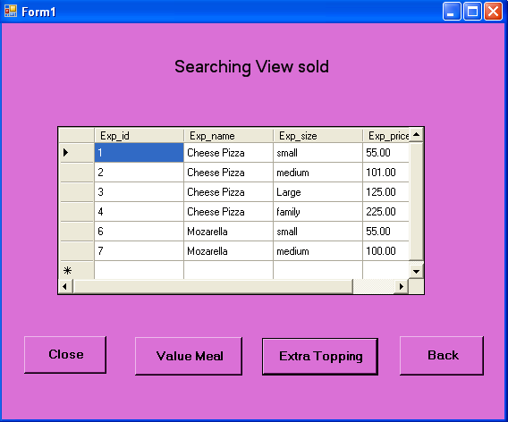

**CODIND:**

Imports System.Data.Sql

Imports System.Data.SqlClient

Public Class searchveiwsold

Private Sub btnvaluemeal_Click(ByVal sender As System.Object, ByVal e As System.EventArgs) Handles btnvaluemeal.Click

cn.Open()

Dim da As New SqlDataAdapter("select * from value_meal", cn)

Dim ds As New DataSet

da.Fill(ds, "value_meal")

DataGridView1.DataSource = ds.Tables(0)

cn.Close()

End Sub

Private Sub btnextratopping_Click(ByVal sender As System.Object, ByVal e As System.EventArgs) Handles btnextratopping.Click

cn.Open()

Dim da As New SqlDataAdapter("select * from Extra_topping_list", cn)

Dim ds As New DataSet

da.Fill(ds, "Extra_topping_list")

DataGridView1.DataSource = ds.Tables(0)

cn.Close()

End Sub

Private Sub btnback_Click(ByVal sender As System.Object, ByVal e As System.EventArgs) Handles btnback.Click

frmviewsold.Show()

End Sub

Private Sub btnclose_Click(ByVal sender As System.Object, ByVal e As System.EventArgs) Handles btnclose.Click

End

End Sub

End Class

* **CUSTOMER DETAILS:**

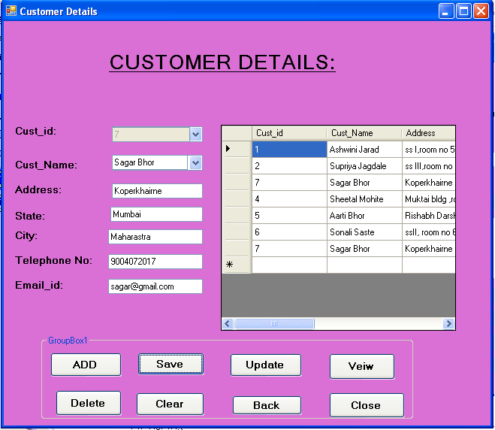

**CODING:**

Imports System.Data.Sql

Imports System.Data.SqlClient

Public Class frmcustomerdetails1

Dim i As String

Private Sub btnclear_Click(ByVal sender As System.Object, ByVal e As System.EventArgs) Handles btnclear.Click

cboid.Text = ""

cboname.Text = ""

txtadd.Text = ""

txtstate.Text = ""

txtcity.Text = ""

txttel.Text = ""

txtemail.Text = ""

txtname.Text = ""

txtid.Text = ""

End Sub

Private Sub btnveiw_Click(ByVal sender As System.Object, ByVal e As System.EventArgs) Handles btnveiw.Click

Try

Dim da As New SqlDataAdapter("select * from Customer_details", cn)

Dim ds As New DataSet

da.Fill(ds, "Customer_details")

DataGridView1.DataSource = ds.Tables(0)

Catch ex As Exception

MsgBox(ex.Message, MsgBoxStyle.Critical, Me.Text)

If cn.State = ConnectionState.Open Then

cn.Close()

End If

End Try

End Sub

Private Sub btnsave_Click(ByVal sender As System.Object, ByVal e As System.EventArgs) Handles btnsave.Click

Dim cmd As New SqlCommand("insert into Customer_details values( '" & txtid.Text & " ','" & txtname.Text & "','" & txtadd.Text & "','" & txtstate.Text & "','" & txtcity.Text & "','" & txttel.Text & "','" & txtemail.Text & "')", cn)

cn.Open()

cmd.ExecuteNonQuery()

MsgBox("Record are successfully.....", MsgBoxStyle.OkOnly + MsgBoxStyle.Information)

txtid.Visible = True

cboname.Enabled = True

cn.Close()

cboid.Items.Clear()

Dim cmds As New SqlCommand("select * from Customer_details", cn)

cn.Open()

Dim dr As SqlDataReader = cmds.ExecuteReader

While dr.Read

cboid.Items.Add(dr.GetString(0))

End While

dr.Close()

cn.Close()

Dim da As New SqlDataAdapter("select * from Customer_details", cn)

Dim ds As New DataSet

da.Fill(ds, "Customer_details")

DataGridView1.DataSource = ds.Tables(0)

End Sub

Private Sub cboname_SelectedIndexChanged(ByVal sender As System.Object, ByVal e As System.EventArgs) Handles cboname.SelectedIndexChanged

If cn.State = ConnectionState.Open Then

cn.Close()

End If

Dim cmd As New SqlCommand("select * from Customer_details where Cust_Name='" & cboname.Text & "'", cn)

cn.Open()

Dim dr As SqlDataReader = cmd.ExecuteReader

While dr.Read

txtid.Visible = True

cboid.Visible = False

txtname.Visible = False

txtid.Text = dr.GetString(0)

txtadd.Text = dr.GetString(2)

txtstate.Text = dr.GetString(3)

txtcity.Text = dr.GetString(4)

txttel.Text = dr.GetString(5)

txtemail.Text = dr.GetString(6)

End While

dr.Close()

cn.Close()

End Sub

Private Sub cboid_SelectedIndexChanged(ByVal sender As System.Object, ByVal e As System.EventArgs) Handles cboid.SelectedIndexChanged

If cn.State = ConnectionState.Open Then

cn.Close()

End If

Dim cmd As New SqlCommand("select * from Customer_details where Cust_id='" & cboid.Text & "'", cn)

cn.Open()

Dim dr As SqlDataReader = cmd.ExecuteReader

While dr.Read

txtid.Visible = False

cboid.Visible = True

txtname.Visible = True

cboname.Visible = False

txtname.Text = dr.GetString(1)

txtadd.Text = dr.GetString(2)

txtstate.Text = dr.GetString(3)

txtcity.Text = dr.GetString(4)

txttel.Text = dr.GetString(5)

txtemail.Text = dr.GetString(6)

End While

dr.Close()

cn.Close()

End Sub

Private Sub frmcustomerdetails1_Load(ByVal sender As System.Object, ByVal e As System.EventArgs) Handles MyBase.Load

Dim cmd As New SqlCommand("select * from Customer_details", cn)

cn.Open()

Dim dr As SqlDataReader = cmd.ExecuteReader

While dr.Read

cboid.Items.Add(dr.GetString(0))

End While

dr.Close()

cn.Close()

Dim cmd1 As New SqlCommand("select * from Customer_details", cn)

cn.Open()

Dim dr1 As SqlDataReader = cmd.ExecuteReader

While dr1.Read

cboname.Items.Add(dr1.GetString(1))

End While

dr1.Close()

cn.Close()

End Sub

Private Sub btnclose_Click(ByVal sender As System.Object, ByVal e As System.EventArgs) Handles btnclose.Click

End

End Sub

Private Sub btnupdate_Click(ByVal sender As System.Object, ByVal e As System.EventArgs) Handles btnupdate.Click

Dim cmd As New SqlCommand("update Customer_details set Cust_Name='" & DataGridView1.CurrentRow.Cells.Item(1).Value & "',Address='" & DataGridView1.CurrentRow.Cells.Item(2).Value & "',State='" & DataGridView1.CurrentRow.Cells.Item(3).Value & "',Telephon_No='" & DataGridView1.CurrentRow.Cells.Item(4).Value & "',Email_id='" & DataGridView1.CurrentRow.Cells.Item(5).Value & "' where Cust_id='" & i & "'", cn)

cn.Open()

cmd.ExecuteNonQuery()

MsgBox("Record are updated successfully......")

cn.Close()

Dim da As New SqlDataAdapter("select * from Customer_details", cn)

Dim ds As New DataSet

da.Fill(ds, "List_of_Ingredients_entry")

DataGridView1.DataSource = ds.Tables(0)

End Sub

Private Sub DataGridView1_ColumnHeaderMouseClick(ByVal sender As Object, ByVal e As System.Windows.Forms.DataGridViewCellMouseEventArgs) Handles DataGridView1.ColumnHeaderMouseClick

i = InputBox("please enter the name of the product")

Dim da As New SqlDataAdapter("select * from Customer_details where name='" & i & "'", cn)

Dim ds As New DataSet

da.Fill(ds, "Customer_details")

DataGridView1.DataSource = ds.Tables(0)

End Sub

Private Sub btnadd_Click(ByVal sender As System.Object, ByVal e As System.EventArgs) Handles btnadd.Click

Dim rec As New SqlCommand("select * from Customer_details", cn)

cn.Open()

Dim dr As SqlDataReader = rec.ExecuteReader

While dr.Read

txtid.Text = dr(0)

End While

txtid.Text = Val(txtid.Text) + 1

dr.Close()

cn.Close()

txtid.Visible = True

txtid.Enabled = False

txtname.Visible = True

cboid.Text = ""

cboname.Text = ""

txtadd.Text = ""

txtstate.Text = ""

txtcity.Text = ""

txttel.Text = ""

txtemail.Text = ""

txtname.Text = ""

End Sub

Private Sub btndelete_Click(ByVal sender As System.Object, ByVal e As System.EventArgs) Handles btndelete.Click

Try

Dim cmd As New SqlCommand("Delete from Customer_details where Cust_id='" & cboid.Text & "'", cn)

cn.Open()

cmd.ExecuteNonQuery()

MsgBox("Successfully Record Deleted.....!", MsgBoxStyle.Information, Me.Text)

cn.Close()

txtname.Text = ""

txtadd.Text = ""

txtcity.Text = ""

txtemail.Text = ""

txtid.Text = ""

txttel.Text = ""

cboid.Items.Clear()

Dim cmd1 As New SqlCommand("select * from Customer_details", cn)

cn.Open()

Dim dr As SqlDataReader = cmd1.ExecuteReader

While dr.Read

cboid.Items.Add(dr.GetString(0))

End While

dr.Close()

cn.Close()

Dim da As New SqlDataAdapter("select * from Customer_details", cn)

Dim ds As New DataSet

da.Fill(ds, "Customer_details")

DataGridView1.DataSource = ds.Tables(0)

Catch ex As Exception

MsgBox(ex.Message, MsgBoxStyle.Critical, Me.Text)

If cn.State = ConnectionState.Open Then

cn.Close()

End If

End Try

End Sub

Private Sub btnback_Click(ByVal sender As System.Object, ByVal e As System.EventArgs) Handles btnback.Click

Me.Hide()

frmMdiParent.Show()

End Sub

Private Sub txtid_TextChanged(ByVal sender As System.Object, ByVal e As System.EventArgs) Handles txtid.TextChanged

End Sub

End Class

* **CUSTOMER PURCHASING ITEM:**

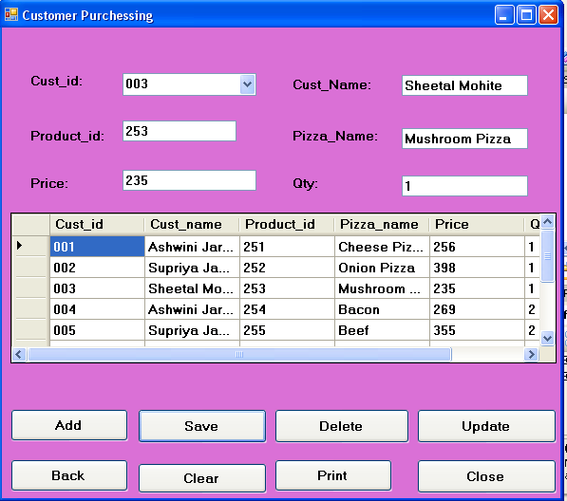

**CODING:**

Imports System.Data.Sql

Imports System.Data.SqlClient

Public Class frmcustomerpurchessing

Dim i As String

Private Sub cbocustid_SelectedIndexChanged(ByVal sender As System.Object, ByVal e As System.EventArgs) Handles cbocustid.SelectedIndexChanged

If cn.State = ConnectionState.Open Then

cn.Close()

End If

Try

Dim cmd As New SqlCommand("select * from Customer_Purchessing where Cust_id='" & cbocustid.Text & "'", cn)

cn.Open()

Dim dr As SqlDataReader = cmd.ExecuteReader

While dr.Read

txtcustname.Text = dr.GetString(1)

txtproductid.Text = dr.GetString(2)

txtpizzaname.Text = dr.GetString(3)

txtprice.Text = dr.GetString(4)

txtqty.Text = dr.GetString(5)

txtproductid.Visible = True

cboproductid.Visible = False

txtcustid.Visible = False

End While

dr.Close()

cn.Close()

cbocustid.Items.Clear()

Dim cmd1 As New SqlCommand("select * from Customer_Purchessing ", cn)

cn.Open()

Dim dr1 As SqlDataReader = cmd1.ExecuteReader

While dr1.Read

cbocustid.Items.Add(dr1.GetString(0))

' cboproductid.Items.Add(dr.GetString(2))

End While

dr.Close()

cn.Close()

Catch ex As Exception

MsgBox(ex.Message, MsgBoxStyle.Critical, Me.Text)

If cn.State = ConnectionState.Open Then

cn.Close()

End If

End Try

End Sub

Private Sub cboproductid_SelectedIndexChanged(ByVal sender As System.Object, ByVal e As System.EventArgs) Handles cboproductid.SelectedIndexChanged

If cn.State = ConnectionState.Open Then

cn.Close()

End If

Try

Dim cmd As New SqlCommand("select * from Customer_Purchessing where Product_id='" & cboproductid.Text & "'", cn)

cn.Open()

Dim dr2 As SqlDataReader = cmd.ExecuteReader

While dr2.Read

txtcustid.Text = dr2.GetString(0)

txtcustname.Text = dr2.GetString(1)

txtpizzaname.Text = dr2.GetString(3)

txtprice.Text = dr2.GetString(4)

txtqty.Text = dr2.GetString(5)

txtcustid.Visible = True

cbocustid.Visible = False

cboproductid.Items.Clear()

Dim cmd1 As New SqlCommand("select * from Customer_Purchessing ", cn)

cn.Open()

Dim dr As SqlDataReader = cmd1.ExecuteReader

While dr.Read

'cbocustid.Items.Add(dr.GetString(0))

cboproductid.Items.Add(dr.GetString(2))

End While

dr.Close()

cn.Close()

End While

dr2.Close()

cn.Close()

Catch ex As Exception

MsgBox(ex.Message, MsgBoxStyle.Critical, Me.Text)

If cn.State = ConnectionState.Open Then

cn.Close()

End If

End Try

End Sub

Private Sub frmcustomerpurchessing_Load(ByVal sender As System.Object, ByVal e As System.EventArgs) Handles MyBase.Load

Try

Dim cmd As New SqlCommand("select * from Customer_Purchessing ", cn)

cn.Open()

Dim dr As SqlDataReader = cmd.ExecuteReader

While dr.Read

cbocustid.Items.Add(dr.GetString(0))

cboproductid.Items.Add(dr.GetString(2))

End While

dr.Close()

cn.Close()

Catch ex As Exception

MsgBox(ex.Message, MsgBoxStyle.Critical, Me.Text)

If cn.State = ConnectionState.Open Then

cn.Close()

End If

End Try

End Sub

Private Sub btnsave_Click(ByVal sender As System.Object, ByVal e As System.EventArgs) Handles btnsave.Click

Try

Dim cmd As New SqlCommand("insert into Customer_Purchessing values( '" & txtcustid.Text & " ','" & txtcustname.Text & "','" & txtproductid.Text & "','" & txtpizzaname.Text & "','" & txtprice.Text & "','" & txtqty.Text & "')", cn)

cn.Open()

cmd.ExecuteNonQuery()

MsgBox("Record are successfully.....", MsgBoxStyle.OkOnly + MsgBoxStyle.Information)

cn.Close()

Dim da As New SqlDataAdapter("select * from Customer_Purchessing", cn)

cn.Open()

Dim ds As New DataSet

da.Fill(ds, "Customer_Purchessing")

DataGridView1.DataSource = ds.Tables(0)

cn.Close()

Catch ex As Exception

MsgBox(ex.Message, MsgBoxStyle.Critical, Me.Text)

If cn.State = ConnectionState.Open Then

cn.Close()

End If

End Try

End Sub

Private Sub btnadd_Click(ByVal sender As System.Object, ByVal e As System.EventArgs) Handles btnadd.Click

Try

Dim rec As New SqlCommand("select * from Customer_Purchessing", cn)

cn.Open()

Dim dr As SqlDataReader = rec.ExecuteReader

While dr.Read

txtcustid.Text = dr.GetString(0)

End While

txtcustid.Text = "00" & Val(txtcustid.Text) + 1

dr.Close()

cn.Close()

txtcustid.Enabled = False

txtproductid.Visible = True

txtcustid.Visible = True

cbocustid.Visible = False

cboproductid.Visible = False

Catch ex As Exception

MsgBox(ex.Message, MsgBoxStyle.Critical, Me.Text)

If cn.State = ConnectionState.Open Then

cn.Close()

End If

End Try

End Sub

Private Sub btnclose_Click(ByVal sender As System.Object, ByVal e As System.EventArgs) Handles btnclose.Click

End

End Sub

Private Sub btndelete_Click(ByVal sender As System.Object, ByVal e As System.EventArgs) Handles btndelete.Click

Try

Dim cmd As New SqlCommand("Delete from Customer_Purchessing where Cust_id='" & cbocustid.Text & "'", cn)

cn.Open()

cmd.ExecuteNonQuery()

MsgBox("Successfully Record Deleted.....!", MsgBoxStyle.Information, Me.Text)

cn.Close()

txtcustid.Text = ""

txtpizzaname.Text = ""

txtprice.Text = ""

cboproductid.Text = ""

txtcustname.Text = ""

txtqty.Text = ""

Dim da As New SqlDataAdapter("select * from Customer_Purchessing", cn)

cn.Open()

Dim ds As New DataSet

da.Fill(ds, "Customer_Purchessing")

DataGridView1.DataSource = ds.Tables(0)

cn.Close()

Catch ex As Exception

MsgBox(ex.Message, MsgBoxStyle.Critical, Me.Text)

If cn.State = ConnectionState.Open Then

cn.Close()

End If

End Try

End Sub

Private Sub btnupdate_Click(ByVal sender As System.Object, ByVal e As System.EventArgs) Handles btnupdate.Click

Try

Dim cmd1 As New SqlCommand("update Customer_Purchessing set Cust_name='" & DataGridView1.CurrentRow.Cells.Item(1).Value & "',Product_id='" & DataGridView1.CurrentRow.Cells.Item(2).Value & "',Pizza_name='" & DataGridView1.CurrentRow.Cells.Item(3).Value & "',Price='" & DataGridView1.CurrentRow.Cells.Item(4).Value & "',Qty='" & DataGridView1.CurrentRow.Cells.Item(5).Value & "' where Cust_id='" & i & "'", cn)

cn.Open()

cmd1.ExecuteNonQuery()

MsgBox("Record are updated successfully......")

cn.Close()

Dim da As New SqlDataAdapter("select * from Customer_Purchessing", cn)

cn.Open()

Dim ds As New DataSet

da.Fill(ds, "Customer_Purchessing")

DataGridView1.DataSource = ds.Tables(0)

cn.Close()

Catch ex As Exception

MsgBox(ex.Message, MsgBoxStyle.Critical, Me.Text)

If cn.State = ConnectionState.Open Then

cn.Close()

End If

End Try

End Sub

Private Sub DataGridView1_CellContentClick(ByVal sender As System.Object, ByVal e As System.Windows.Forms.DataGridViewCellEventArgs) Handles DataGridView1.CellContentClick

Try

i = InputBox("please enter the name of the product")

Dim da As New SqlDataAdapter("select * from Customer_Purchessing where cust_name='" & i & "'", cn)

Dim ds As New DataSet

da.Fill(ds, "Customer_Purchessing")

DataGridView1.DataSource = ds.Tables(0)

Catch ex As Exception

MsgBox(ex.Message, MsgBoxStyle.Critical, Me.Text)

If cn.State = ConnectionState.Open Then

cn.Close()

End If

End Try

End Sub

Private Sub btnclear_Click(ByVal sender As System.Object, ByVal e As System.EventArgs) Handles btnclear.Click

'txtcustid.Text = ""

txtproductid.Text = ""

txtpizzaname.Text = ""

txtprice.Text = ""

cboproductid.Text = ""

txtcustname.Text = ""

txtqty.Text = ""

End Sub

End Class

* **CUSTOMER BILL:**

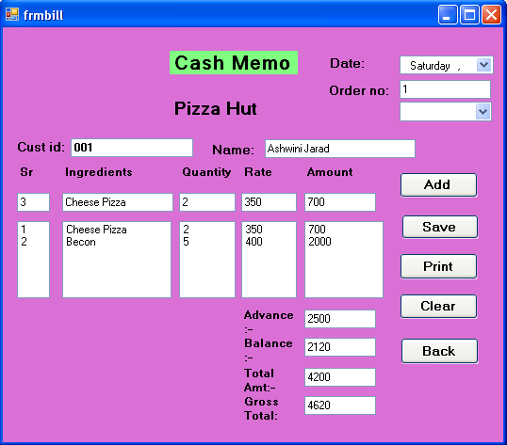

**CODING:**

Imports System.Data.Sql

Imports System.Data.SqlClient

Public Class frmbill

Private Sub btnadd_Click(ByVal sender As System.Object, ByVal e As System.EventArgs) Handles btnadd.Click

Try

DateTimePicker1.Text = ""

txtname.Text = ""

txtsrno.Text = ""

txtingredients.Text = ""

txtquantity.Text = ""

txtrate.Text = ""

txtamount.Text = ""

txtgrossamt.Text = ""

txtadvance.Text = ""

txtbalance.Text = ""

Dim rec As New SqlCommand("select * from Cash_Memo", cn)

cn.Open()

Dim drcash As SqlDataReader = rec.ExecuteReader

While drcash.Read

txtordno.Text = drcash.GetString(0)

End While

txtordno.Text = Val(txtordno.Text) + 1

drcash.Close()

cn.Close()

Catch ex As Exception

MsgBox(ex.Message, MsgBoxStyle.Critical, Me.Text)

If cn.State = ConnectionState.Open Then

cn.Close()

End If

End Try

End Sub

Private Sub cboorderno_SelectedIndexChanged(ByVal sender As System.Object, ByVal e As System.EventArgs) Handles cboorderno.SelectedIndexChanged

If cn.State = ConnectionState.Open Then

cn.Close()

End If

Try

Dim cmd As New SqlCommand("select * from Cash_Memo where Order_no='" & cboorderno.Text & "'", cn)

cn.Open()

Dim dr As SqlDataReader = cmd.ExecuteReader

While dr.Read

txtsrno.Text = dr.GetString(1)

txtingredients.Text = dr.GetString(2)

txtquantity.Text = dr.GetString(3)

txtrate.Text = dr.GetString(4)

txtamount.Text = dr.GetString(5)

txttotalamt.Text = dr.GetString(6)

txtgrossamt.Text = dr.GetString(7)

txtname.Text = dr.GetString(9)

txtadvance.Text = dr.GetString(10)

txtbalance.Text = dr.GetString(11)

End While

dr.Close()

cn.Close()

Catch ex As Exception

MsgBox(ex.Message, MsgBoxStyle.Critical, Me.Text)

If cn.State = ConnectionState.Open Then

cn.Close()

End If

End Try

End Sub

Private Sub frmbill_Load(ByVal sender As System.Object, ByVal e As System.EventArgs) Handles MyBase.Load

Try

Dim cmd As New SqlCommand("select * from Cash_Memo", cn)

cn.Open()

Dim dr As SqlDataReader = cmd.ExecuteReader

While dr.Read

cboorderno.Items.Add(dr(0))

End While

dr.Close()

cn.Close()

Catch ex As Exception

MsgBox(ex.Message, MsgBoxStyle.Critical, Me.Text)

If cn.State = ConnectionState.Open Then

cn.Close()

End If

End Try

End Sub

Private Sub btnsave_Click(ByVal sender As System.Object, ByVal e As System.EventArgs) Handles btnsave.Click

Try

Dim i As Integer

For i = 0 To lstsrno.Items.Count - 1

Dim cmds As New SqlCommand("insert into Cash_Memo values('" & txtordno.Text & "','" & lstsrno.Items.Item(i) & "','" & lstparticular.Items.Item(i) & "','" & lstqty.Items.Item(i) & "','" & lstrate.Items.Item(i) & "','" & lstamt.Items.Item(i) & "','" & txttotalamt.Text & "','" & txtgrossamt.Text & "','" & DateTimePicker1.Value & "','" & txtname.Text & "','" & txtadvance.Text & "','" & txtbalance.Text & "')", cn)

cn.Open()

cmds.ExecuteNonQuery()

cn.Close()

Next

MsgBox("Record are saved...!", MsgBoxStyle.OkOnly + MsgBoxStyle.Question, "saved")

cboorderno.Items.Clear()

Dim cmd As New SqlCommand("select * from Cash_Memo", cn)

cn.Open()

Dim dr As SqlDataReader = cmd.ExecuteReader

While dr.Read

cboorderno.Items.Add(dr(0))

End While

dr.Close()

cn.Close()

Catch ex As Exception

MsgBox(ex.Message, MsgBoxStyle.Critical, Me.Text)

If cn.State = ConnectionState.Open Then

cn.Close()

End If

End Try

End Sub

Private Sub btnclear_Click(ByVal sender As System.Object, ByVal e As System.EventArgs) Handles btnclear.Click

Try

DateTimePicker1.Text = ""

cboorderno.Text = ""

txtname.Text = ""

txtsrno.Text = ""

txtingredients.Text = ""

txtquantity.Text = ""

txtrate.Text = ""

txtamount.Text = ""

txtgrossamt.Text = ""

txtadvance.Text = ""

txtbalance.Text = ""

Catch ex As Exception

MsgBox(ex.Message, MsgBoxStyle.Critical, Me.Text)

If cn.State = ConnectionState.Open Then

cn.Close()

End If

End Try

End Sub

Private Sub btncancel_Click(ByVal sender As System.Object, ByVal e As System.EventArgs) Handles btncancel.Click

Me.Hide()

frmmdiparent.Show()

End Sub

Private Sub txtgrossamt_GotFocus(ByVal sender As Object, ByVal e As System.EventArgs) Handles txtgrossamt.GotFocus

Try

txtgrossamt.Text = Val(txttotalamt.Text) + Val(txttotalamt.Text * 10 / 100)

Catch ex As Exception

MsgBox(ex.Message, MsgBoxStyle.Critical, Me.Text)

If cn.State = ConnectionState.Open Then

cn.Close()

End If

End Try

End Sub

Private Sub txtamount_LostFocus(ByVal sender As Object, ByVal e As System.EventArgs) Handles txtamount.LostFocus

Try

lstsrno.Items.Add(txtsrno.Text)

lstparticular.Items.Add(txtingredients.Text)

lstqty.Items.Add(txtquantity.Text)

lstrate.Items.Add(txtrate.Text)

lstamt.Items.Add(txtamount.Text)

Dim cmdamt As New SqlCommand("insert into ADDITION values(" & txtamount.Text & ")", cn)

cn.Open()

cmdamt.ExecuteNonQuery()

cn.Close()

txtingredients.Text = ""

txtquantity.Text = ""

txtrate.Text = ""

txtamount.Text = ""

txtcustid.Text = ""

txtname.Text = ""

Catch ex As Exception

MsgBox(ex.Message, MsgBoxStyle.Critical, Me.Text)

If cn.State = ConnectionState.Open Then

cn.Close()

End If

End Try

End Sub

Private Sub txtquantity_TextChanged(ByVal sender As System.Object, ByVal e As System.EventArgs) Handles txtquantity.TextChanged

Try

txtamount.Text = Val(txtquantity.Text) * Val(txtrate.Text)

Catch ex As Exception

MsgBox(ex.Message, MsgBoxStyle.Critical, Me.Text)

If cn.State = ConnectionState.Open Then

cn.Close()

End If

End Try

End Sub

Private Sub txttotalamt_GotFocus(ByVal sender As Object, ByVal e As System.EventArgs) Handles txttotalamt.GotFocus

Try

Dim cmdadd As New SqlCommand("select sum(SUM1) from ADDITION", cn)

cn.Open()

Dim dradd As SqlDataReader = cmdadd.ExecuteReader

While dradd.Read

txttotalamt.Text = dradd(0)

End While

dradd.Close()

cn.Close()

Dim cmddel As New SqlCommand("delete from ADDITION", cn)

cn.Open()

cmddel.ExecuteNonQuery()

cn.Close()

Catch ex As Exception

MsgBox(ex.Message, MsgBoxStyle.Critical, Me.Text)

If cn.State = ConnectionState.Open Then

cn.Close()

End If

End Try

End Sub

Private Sub txtbalance_GotFocus(ByVal sender As Object, ByVal e As System.EventArgs) Handles txtbalance.GotFocus

Try

txtbalance.Text = Val(txtgrossamt.Text) - Val(txtadvance.Text)

Catch ex As Exception

MsgBox(ex.Message, MsgBoxStyle.Critical, Me.Text)

If cn.State = ConnectionState.Open Then

cn.Close()

End If

End Try

End Sub

Private Sub txtcustid_LostFocus(ByVal sender As Object, ByVal e As System.EventArgs) Handles txtcustid.LostFocus

Try

Dim cmdid As New SqlCommand("select * from Customer_Purchessing where Cust_id='" & txtcustid.Text & "'", cn)

cn.Open()

Dim drid As SqlDataReader = cmdid.ExecuteReader

While drid.Read

txtname.Text = drid.GetString(1)

txtingredients.Text = drid.GetString(3)

txtrate.Text = drid.GetString(4)

End While

drid.Close()

cn.Close()

txtquantity.Focus()

txtsrno.Text = Val(txtsrno.Text) + 1

Catch ex As Exception

MsgBox(ex.Message, MsgBoxStyle.Critical, Me.Text)

If cn.State = ConnectionState.Open Then

cn.Close()

End If

End Try

End Sub

Private Sub txtamount_TextChanged(ByVal sender As System.Object, ByVal e As System.EventArgs) Handles txtamount.TextChanged

End Sub

End Class

**EMPLOYEE DETAILS:**

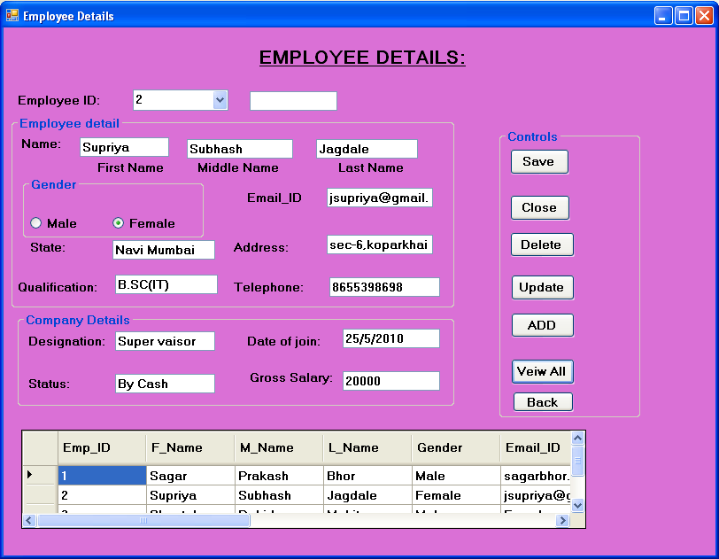

**CODING:**

Imports System.Data.Sql

Imports System.Data.SqlClient

Public Class frmemployeedetails

Private Sub btnclose_Click(ByVal sender As System.Object, ByVal e As System.EventArgs) Handles btnclose.Click

End

End Sub

Private Sub btnsave_Click(ByVal sender As System.Object, ByVal e As System.EventArgs) Handles btnsave.Click

Dim cmd As New SqlCommand("insert into Employee_Details values('" & cboid.Text & "','" & txtfname.Text & "','" & txtmname.Text & "','" & txtlname.Text & "','" & rbtnmale.Text & "','" & rbtnfemale.Text & "','" & txtadd.Text & "','" & txtstate.Text & "','" & txtqualification.Text & "','" & txttelephone.Text & "','" & txtdes.Text & "','" & txtdate.Text & "','" & txtstatu.Text & "','" & txtgross.Text & "')", cn)

cn.Open()

cmd.ExecuteNonQuery()

MsgBox("Records are successfully....", MsgBoxStyle.Information + MsgBoxStyle.OkOnly)

cn.Close()

Dim da As New SqlDataAdapter("select * from Employee_Details", cn)

Dim ds As New DataSet

da.Fill(ds, "Employee_Details")

DataGridView1.DataSource = ds.Tables("Employee_Details")

End Sub

Private Sub btnveiw_Click(ByVal sender As System.Object, ByVal e As System.EventArgs) Handles btnveiw.Click

Dim da As New SqlDataAdapter("select * from Employee_Details", cn)

Dim ds As New DataSet

da.Fill(ds, "Employee_Details")

DataGridView1.DataSource = ds.Tables("Employee_Details")

End Sub

Private Sub btndelete_Click(ByVal sender As System.Object, ByVal e As System.EventArgs) Handles btndelete.Click

Dim cmd As New SqlCommand("delete from Employee_Details where Emp_ID='" & cboid.Text & "'", cn)

cn.Open()

cmd.ExecuteNonQuery()

MsgBox(" Record are successfully deleted", MsgBoxStyle.Information + MsgBoxStyle.OkOnly)

cn.Close()

cboid.Text = ""

txtadd.Text = ""

txtdate.Text = ""

txtdes.Text = ""

txtemail.Text = ""

txtfname.Text = ""

txtgross.Text = ""

txtid.Text = ""

txtlname.Text = ""

txtmname.Text = ""

txtqualification.Text = ""

txtstate.Text = ""

txtstatu.Text = ""

txttelephone.Text = ""

End Sub

Private Sub cboid_SelectedIndexChanged(ByVal sender As System.Object, ByVal e As System.EventArgs) Handles cboid.SelectedIndexChanged

Dim cmd As New SqlCommand("select * from Employee_Details where Emp_ID='" & cboid.Text & "'", cn)

cn.Open()

Dim dr As SqlDataReader = cmd.ExecuteReader

While dr.Read

cboid.Text = dr.GetString(0)

txtfname.Text = dr.GetString(1)

txtmname.Text = dr.GetString(2)

txtlname.Text = dr.GetString(3)

txtgender.Text = dr.GetString(4)

If txtgender.Text = "Male" Then

rbtnmale.Checked = True

txtgender.Visible = False

ElseIf txtgender.Text = "Female" Then

rbtnfemale.Checked = True

txtgender.Visible = False

End If

txtemail.Text = dr.GetString(5)

txtstate.Text = dr.GetString(6)

txtadd.Text = dr.GetString(7)

txtqualification.Text = dr.GetString(8)

txttelephone.Text = dr.GetString(9)

txtdes.Text = dr.GetString(10)

txtdate.Text = dr.GetString(11)

txtstatu.Text = dr.GetString(12)

txtgross.Text = dr.GetString(13)

End While

dr.Close()

cn.Close()

End Sub

Private Sub frmemployeedetails_Load(ByVal sender As System.Object, ByVal e As System.EventArgs) Handles MyBase.Load

Dim cmda As New SqlCommand("select * from Employee_Details", cn)

cn.Open()

Dim dr As SqlDataReader = cmda.ExecuteReader

While dr.Read

cboid.Items.Add(dr.GetString(0))

End While

dr.Close()

cn.Close()

End Sub

Private Sub rbtnmale_CheckedChanged(ByVal sender As System.Object, ByVal e As System.EventArgs) Handles rbtnmale.CheckedChanged

txtgender.Text = "Male"

End Sub

Private Sub rbtnfemale_CheckedChanged(ByVal sender As System.Object, ByVal e As System.EventArgs) Handles rbtnfemale.CheckedChanged

txtgender.Text = "Female"

End Sub

Private Sub btnback_Click(ByVal sender As System.Object, ByVal e As System.EventArgs) Handles btnback.Click

Me.Hide()

frmMdiParent.Show()

End Sub

Private Sub txtgender_TextChanged(ByVal sender As System.Object, ByVal e As System.EventArgs) Handles txtgender.TextChanged

End Sub

End Class

* **EMPLOYEE DETAILS**

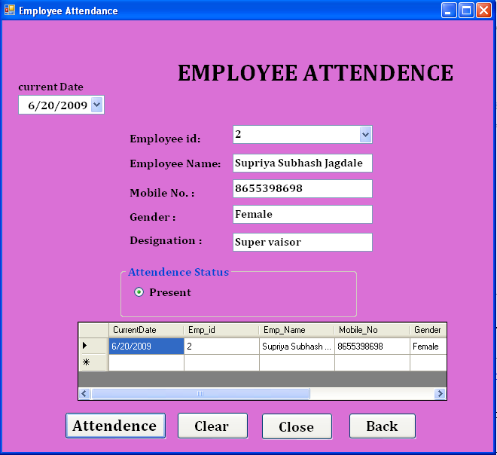

**CODING:**

Imports System.Data.Sql

Imports System.Data.SqlClient

Public Class frmEmployeeAttendence

Private Sub EmployeeAttendence_Load(ByVal sender As System.Object, ByVal e As System.EventArgs) Handles MyBase.Load

Try

DateTimePicker1.Value = Now.Date

If cn.State = ConnectionState.Open Then

cn.Close()

End If

Dim cmdemp As New SqlCommand("select * from Employee_Details order by Emp_ID", cn)

cn.Open()

Dim dremp As SqlDataReader = cmdemp.ExecuteReader

While dremp.Read

cboempid.Items.Add(dremp.GetString(0))

End While

dremp.Close()

cn.Close()

txtpre.Visible = False

Catch ex As Exception

MsgBox(ex.Message, MsgBoxStyle.Critical, Me.Text)

If cn.State = ConnectionState.Open Then

cn.Close()

End If

End Try

End Sub

Private Sub cboempid_SelectedIndexChanged(ByVal sender As System.Object, ByVal e As System.EventArgs) Handles cboempid.SelectedIndexChanged

Try

Dim cmdat As New SqlCommand("select * from Employee_Details where Emp_ID='" & cboempid.Text & "'", cn)

cn.Open()

Dim drat As SqlDataReader = cmdat.ExecuteReader

While drat.Read

txtempname.Text = drat.GetString(1) & " " & drat.GetString(2) & " " & drat.GetString(3)

txtempmobno.Text = drat(9)

txtgender.Text = drat.GetString(4)

txtdesignation.Text = drat.GetString(10)

End While

drat.Close()

cn.Close()

Catch ex As Exception

MsgBox(ex.Message, MsgBoxStyle.Critical, Me.Text)

If cn.State = ConnectionState.Open Then

cn.Close()

End If

End Try

End Sub

Private Sub RadioButton1_CheckedChanged(ByVal sender As System.Object, ByVal e As System.EventArgs) Handles RadioButton1.CheckedChanged

txtpre.Text = "P"

End Sub

Private Sub btnsave_Click(ByVal sender As System.Object, ByVal e As System.EventArgs) Handles btnsave.Click

Try

If RadioButton1.Checked = True Then

Dim cmdsave As New SqlCommand("Insert into EmployeeAttendance values('" & DateTimePicker1.Value & "','" & cboempid.Text & "','" & txtempname.Text & "','" & txtempmobno.Text & "','" & txtgender.Text & "','" & txtdesignation.Text & "','" & txtpre.Text & "')", cn)

cn.Open()

cmdsave.ExecuteNonQuery()

MsgBox("Record Saved Successfully....!", MsgBoxStyle.OkOnly + MsgBoxStyle.Question, "Saved")

cn.Close()

Else

Dim cmdsave As New SqlCommand("Insert into EmployeeAttendance values('" & DateTimePicker1.Value & "','" & cboempid.Text & "','" & txtempname.Text & "','" & txtempmobno.Text & "','" & txtgender.Text & "','" & txtdesignation.Text & "', 'A' )", cn)

cn.Open()

cmdsave.ExecuteNonQuery()

MsgBox("Record Saved Successfully....!", MsgBoxStyle.OkOnly + MsgBoxStyle.Question, "Saved")

cn.Close()

End If

Dim da As New SqlDataAdapter("select * from EmployeeAttendance ", cn)

Dim ds As New DataSet

da.Fill(ds, "EmployeeAttendance")

DataGridView1.DataSource = ds.Tables(0)

Catch ex As Exception

MsgBox(ex.Message, MsgBoxStyle.Critical, Me.Text)

If cn.State = ConnectionState.Open Then

cn.Close()

End If

End Try

End Sub

Private Sub btnclear_Click(ByVal sender As System.Object, ByVal e As System.EventArgs) Handles btnclear.Click

Try

txtdesignation.Text = ""

txtempmobno.Text = ""

txtgender.Text = ""

txtempname.Text = ""

txtpre.Text = ""

RadioButton1.Checked = False

Catch ex As Exception

MsgBox(ex.Message, MsgBoxStyle.Critical, Me.Text)

If cn.State = ConnectionState.Open Then

cn.Close()

End If

End Try

End Sub

Private Sub btnexit_Click(ByVal sender As System.Object, ByVal e As System.EventArgs) Handles btnexit.Click

End

End Sub

Private Sub btnback_Click(ByVal sender As System.Object, ByVal e As System.EventArgs) Handles btnback.Click

Me.Hide()

frmMDIParent.Show()

End Sub

End Class

* **EMPLOYEE PAYMENT SALARY:**

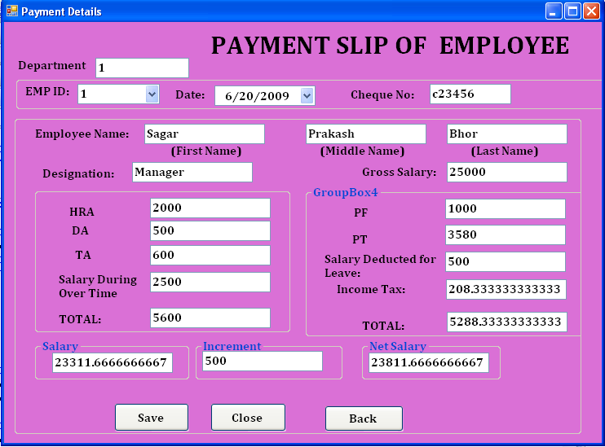

**CODING:**

Imports System.Data.Sql

Imports System.Data.SqlClient

Public Class frmPaymentSlip

Private Sub PaymentSlip_Load(ByVal sender As System.Object, ByVal e As System.EventArgs) Handles MyBase.Load

Try

DateTimePicker1.Value = Now

Dim cmdretrive As New SqlCommand("select * from Employee_Details ", cn)

cn.Open()

Dim dr As SqlDataReader = cmdretrive.ExecuteReader

While dr.Read

cboemp.Items.Add(dr.GetString(0))

End While

dr.Close()

cn.Close()

Catch ex As Exception

MsgBox(ex.Message, MsgBoxStyle.Critical, Me.Text)

If cn.State = ConnectionState.Open Then

cn.Close()

End If

End Try

End Sub

Private Sub cboemp_SelectedIndexChanged(ByVal sender As System.Object, ByVal e As System.EventArgs) Handles cboemp.SelectedIndexChanged

Try

Dim cmdadd As New SqlCommand("select * from Employee_Details where Emp_ID='" & cboemp.Text & "'", cn)

cn.Open()

Dim dr1 As SqlDataReader = cmdadd.ExecuteReader

While dr1.Read

txtdept.Text = dr1.GetString(0)

txtdesignation.Text = dr1.GetString(10)

txtfname.Text = dr1.GetString(1)

txtmname.Text = dr1.GetString(2)

txtlname.Text = dr1.GetString(3)

txtgrossSalary.Text = dr1.GetString(13)

End While

dr1.Close()

cn.Close()

Dim cmdre As New SqlCommand("select * from Salarydeducted where Emp_ID='" & cboemp.Text & "'", cn)

cn.Open()

Dim drsal As SqlDataReader = cmdre.ExecuteReader

While drsal.Read()

txthra.Text = drsal(1)

txtda.Text = drsal(2)

txtta.Text = drsal(3)

txtpf.Text = drsal(4)

txtpt.Text = drsal(5)

End While

drsal.Close()

cn.Close()

Dim x As String = "A"

Dim cmd2 As New SqlCommand("select count(*) from EmployeeAttendance where Emp_Attendance_Status='" & x & "' and Month(CurrentDate)=" & DatePart(DateInterval.Month, DateTimePicker1.Value) & " and Emp_ID='" & cboemp.Text & "'", cn)

cn.Open()

Dim counta As Integer = cmd2.ExecuteScalar

txtdeductedsalary.Text = counta

txtdeductedsalary.Text = Val(txtdeductedsalary.Text) * ((Val(txtgrossSalary.Text) / 30))

cn.Close()

txttotal.Text = Val(txthra.Text) + Val(txtda.Text) + Val(txtta.Text) + Val(txtsalovertime.Text)

Dim annualsalary As Double = 0.0

annualsalary = Val(txtgrossSalary.Text) * 12

If (annualsalary >= 200000) Then

txttax.Text = Val(txtgrossSalary.Text) * Val(10 / 100)

txttax.Text = Val(txttax.Text / 12)

Else

If (annualsalary > 300000 & annualsalary < 500000) Then

txttax.Text = Val(txtgrossSalary.Text) * Val(12 / 100)

txttax.Text = Val(txttax.Text / 12)

Else

txttax.Text = Val(txtgrossSalary.Text) * Val(15 / 100)

txttax.Text = Val(txttax.Text / 12)

End If

txttotal2.Text = Val(txtpf.Text) + Val(txtpt.Text) + Val(txttax.Text) + Val(txtdeductedsalary.Text)

End If

txttotal2.Text = Val(txtpf.Text) + Val(txtpt.Text) + Val(txttax.Text) + Val(txtdeductedsalary.Text)

txtsalary.Text = Val(txtgrossSalary.Text) + Val(txttotal.Text) - Val(txttotal2.Text)

Catch ex As Exception

MsgBox(ex.Message, MsgBoxStyle.Critical, Me.Text)

If cn.State = ConnectionState.Open Then

cn.Close()

End If

End Try

End Sub

Private Sub btnsave_Click(ByVal sender As System.Object, ByVal e As System.EventArgs) Handles btnsave.Click

Try

Dim cmdsave As New SqlCommand("insert into paymentSlip values('" & txtdept.Text & "','" & cboemp.Text & "','" & DateTimePicker1.Value & "','" & txtcheq.Text & "','" & txtfname.Text & "','" & txtmname.Text & "','" & txtlname.Text & "','" & txtdesignation.Text & "','" & txtgrossSalary.Text & "','" & txthra.Text & "','" & txtda.Text & "','" & txtta.Text & "','" & txtsalovertime.Text & "','" & txtpf.Text & "','" & txtpt.Text & "','" & txtdeductedsalary.Text & "', '" & txttax.Text & "' ,'" & txtnetsalary.Text & "' )", cn)

cn.Open()

cmdsave.ExecuteNonQuery()

MsgBox("Record Saved Successfully....!", MsgBoxStyle.OkOnly + MsgBoxStyle.Question, "Saved")

cn.Close()

Catch ex As Exception

MsgBox(ex.Message, MsgBoxStyle.Critical, Me.Text)

If cn.State = ConnectionState.Open Then

cn.Close()

End If

End Try

End Sub

Private Sub txtnetsalary_GotFocus(ByVal sender As Object, ByVal e As System.EventArgs) Handles txtnetsalary.GotFocus

txtnetsalary.Text = Val(txtsalary.Text) + Val(txtincrement.Text)

End Sub

Private Sub btnback_Click(ByVal sender As System.Object, ByVal e As System.EventArgs) Handles btnback.Click

Me.Hide()

frmMDIParent.Show()

End Sub

Private Sub btnclose_Click(ByVal sender As System.Object, ByVal e As System.EventArgs) Handles btnclose.Click

End

End Sub

Private Sub txtincrement_GotFocus(ByVal sender As Object, ByVal e As System.EventArgs) Handles txtincrement.GotFocus

If txtincrement.Text = "" Then

txtincrement.Text = "0.00"

End If

End Sub

Private Sub txttotal_GotFocus(ByVal sender As Object, ByVal e As System.EventArgs) Handles txttotal.GotFocus

txttotal.Text = Val(txthra.Text) + Val(txtda.Text) + Val(txtta.Text) + Val(txtsalovertime.Text)

End Sub

Private Sub txttotal2_GotFocus(ByVal sender As Object, ByVal e As System.EventArgs) Handles txttotal2.GotFocus

txttotal2.Text = Val(txtpf.Text) + Val(txtpt.Text) + Val(txtdeductedsalary.Text) + Val(txttax.Text)

End Sub

End Class

* **SUPPILER:**

